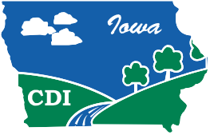
Conservation Districts of Iowa

Larry Beeler Memorial Scholarship Fund

Class of 2017

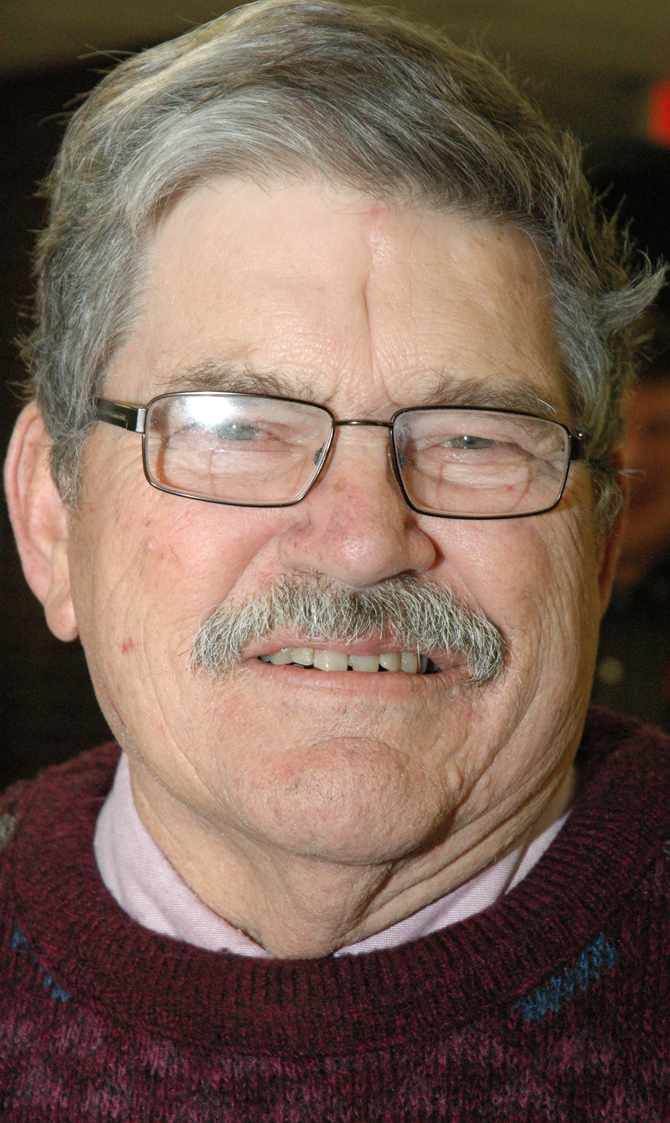

Larry Beeler
February 26, 1936 - December 15, 2012
Madison County, Iowa

Larry received his early education at the Ebenezer Country School and later attended and graduated from Truro Consolidated High School. He then attended Iowa State University until 1957 when he began farming the land that his great-grandfather homesteaded. Larry was very proud that this farm is a Heritage Farm with over 150 years of ownership by the Beeler Family.
Larry was not only a lifetime farmer but he was dedicated to soil conservation in Madison County. He served as Soil and Water Conservation Commissioner for 54 years, was Past President of Conservation Districts of Iowa and also served as Treasurer of the National Association of Conservation Districts, receiving their Distinguished Service Award in 2008.

Larry was united in marriage to Nelda Ruth Swan on December 22, 1956 at the family home. Five children, Donald Bruce, Dale Allen, Larry William, Gary Dean and Rebecca Ruth blessed this union.
Upon Larry’s passing, his family donated funds to CDI for a scholarship in his name.

Conservation Districts of Iowa is privileged to offer the Larry Beeler Memorial Scholarship Fund.

The Region 6 Conservation Scholarship Winner will receive an additional $350 from this scholarship fund in memory of Larry Beeler. This scholarship will be offered through 2018.

