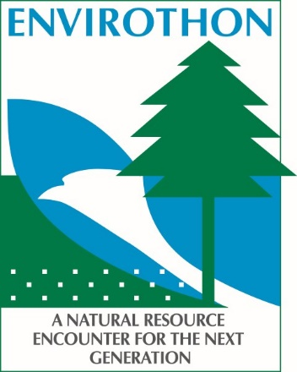
2019 Iowa Envirothon
Put together your five member team TODAY!
Please complete a separate form for each team registration.

Registrations due by Friday, February 1, 2019

School or Club Name
FFA Team

Team Advisor/Coach Address City State Zip Email Phone

Below, please select the Regional Envirothon Competition where you would prefer to compete (1= first choice, 2= second choice) Please list a second choice for a location in case your first option is full. Early registration is recommended, as each site is limited to 16 teams per competition.
Submit registration and payment to:
Conservation Districts of Iowa Attn: Iowa Envirothon
315 E 5th St. Suite 134
Des Moines, IA 50309
Email: admin@cdiowa.org
March 12 – Hawkeye Community College, Waterloo
March 12 – Cherokee Community Center, Cherokee
March 12 – Montgomery CO Fairgrounds, Red Oak
March 19 – Kirkwood Community College, Iowa City
March 20 – DMACC, West Des Moines

$80.00 registration fee per team registration
Make Checks Payable to Conservation Districts of Iowa

Registration is not confirmed until receipt of payment.

Schools often take quite a bit of time to process payments, so please get your request in to your school for the Iowa Envirothon registration fee right away!

Registration fees cover both Regional and State Competition fees for teams who compete at each event. Upon receiving registration and payment, a confirmation of receipt will include further information for both events as they occur.

Questions: Contact Carlee or Brenda at 515-289-8300 or admin@cdiowa.org.

