

Employer
Handbook

A Guide for Managing Human Resources of
Iowa’s Soil and Water Conservation Districts

October 2004
Revised: July 2016
Revised: July 2021

Preface

As a Soil and Water Conservation District (SWCD) Commissioner, you have the statutory power to employ staff. Over the years, SWCD Commissioners and field office staff alike have asked for an employer handbook that is fairly comprehensive, focused on Iowa’s specific rules and regulations and one that is easy to use. This “Employer Handbook: A Guide for Managing Human Resources of Iowa’s Soil and Water Conservation Districts” has been developed to help fulfill that need.

Every effort has been made to make this handbook as useful as possible. Please note that this reference is a very basic resource for you as an employer. Many references and samples are provided to help you be more effective employers, to comply with current laws and to provide a mutually beneficial working environment. Specific details and questions not answered in this handbook may be answered by following up with some of the listed resources.

This entire handbook is available on the CDI website, where it is updated as needed. The many examples can be easily downloaded, customized and saved for use by your district. If you have any questions, feel free to contact Conservation Districts of Iowa, or your field representative at the Division of Soil Conservation and Water Quality or The Natural Resources Conservation Services.

Written in Joint Cooperation by

Conservation Districts of Iowa

Iowa Department of Agriculture and Land Stewardship -
Division of Soil Conservation and Water Quality

And

USDA - Natural Resources Conservation Service

Table of Contents
Foreword 1
Principal Responsibilities – District Commissioners 1
Written Policy 1
Where to Go for Help 2
Other Resources 2
Chapter 1 – Workload, Staffing Needs and Qualifications 4
Workload Analysis 4
Setting Priorities 4
At-Will Employees 4
Chapter 2 – Position Descriptions 5
Writing Position Descriptions 5
Establishing Performance Duties and Standards 6
Establishing Qualifications or Selection Standards 6
Exhibit 2.1 – Position Description Format 8
Exhibit 2.2 – Position Description EXAMPLE (District Conservation Aide) 9
Exhibit 2.3 – Position Description EXAMPLE (District Conservation Technician) 10
Exhibit 2.4 – Position Description EXAMPLE (District Watershed Coordinator) 11
Exhibit 2.5 – Checklist for Developing Position Descriptions 12
Chapter 3 - Recruitment and Hiring 13
Recruitment 13
Employment - Cover Letter & Résumé 13
Equal Employment Opportunity and Anti-Discrimination Policies 13
Anti-Nepotism 14
Conducting the Interview 14
Selection and Follow-Up 15
Personnel Files 15
Exhibit 3.1 – Vacancy Announcement 16
Exhibit 3.2 – Generic Application 17
Exhibit 3.3 – Sample Interview Questions 19
Exhibit 3.4 – Do’s and Don’ts for Interviewing Questions 20
Exhibit 3.5 – Interview Evaluation Form 21
Exhibit 3.6 – Confirmation of Acceptance Letter 22
Exhibit 3.7 – Not Hire Letter 23
Exhibit 3.8 – Checklist for Recruitment and Hiring Employees 24
Chapter 4 – Wages, Taxes, Benefits and Leave 25
Determining Compensation 25
Wage Increases 25
Family and Medical Leave Act of 1993 (FMLA) 25
Determining Leave and Benefits 26
Workers’ Compensation Insurance (Mandatory) 27
Benefits Which Are “Optional” 28
Overtime (When authorized) 29
Emergency Closings 29
District Payroll Required Withholdings 29
Exhibit 4.1 -- Workers’ Compensation – First Report of Injury or Illness 31
Exhibit 4.2 -- Federal W-4 Form 32
Exhibit 4.3 -- Iowa W-4 Form 34
Exhibit 4.4 -- Employment Eligibility Verification 36
Exhibit 4.5 -- Checklist for Wages, Taxes, Benefits and Leave 38
Chapter 5 - Employment 40
New Employee Package 40
Orientation 40
Contracts 40
District Organization and Responsibilities 40
Supervision and Hierarchy 40
Review Job Expectations 40
Hours of Work/Time Reporting Document/Pay Period 41
Equipment and Workstation 41
Travel and Training 42
Tort Liability 42
Bonding 42
Identification 42
Employment Termination 42
Exhibit 5.1 – New Employee Package 43
Exhibit 5.2 – Employee Confidential Emergency Information 44
Exhibit 5.3 – Request for Authorization to Operate Government Vehicle 45
Exhibit 5.4 – Core Conservation Partnership 46
Exhibit 5.5 – Time Reporting Document 47
Exhibit 5.6 – Application for Leave 48
Exhibit 5.7 – Request to Attend Training Sessions 49
Exhibit 5.8 – Acknowledgement of Receipt of Employee Handbook 50
Exhibit 5.9 – Exit Interview 51
Exhibit 5.10 – Record of Exit 53
Exhibit 5.11 – Exit Letter 54
Exhibit 5.12 – Checklist for Employment 55
Chapter 6 - Evaluation 56
The Importance of Objectivity 56
Steps in the Formal Evaluation 56
Guidelines for Evaluating Employee Job Performance 57
Analyzing Poor Performance 58
Employee Response 59
Exhibit 6.1 – Performance Evaluation 60
Exhibit 6.2 – Checklist for Evaluation 63
Chapter 7 – Employee Development 64
Setting training objectives. 64
Deciding how training will be accomplished. 64
Evaluating training. 64
Responsibility for District Employee Development Program. 64
Individual Employee Development Plans. 64
Exhibit 7.1 – Employee Development Plan for District Position 65
Exhibit 7.2– Checklist for Employee Development 67
Chapter 8 – Conduct, Ethics and Discipline 68
Standards of Conduct and Ethics 68
Discipline 70
Written Notifications 71
Exhibit 8.1 – Financial Policies and SWCD employees 72
Exhibit 8.2 – Harassment and Sexual Harassment 73
Exhibit 8.3 – Hatch Act for State and Local Employees 75
Exhibit 8.4 – Letter of Reprimand 76
Exhibit 8.5 – Letter of Suspension 77
Exhibit 8.6 – Letter of Termination 78
Exhibit 8.7 – Checklist for Disciplinary Action 79
Chapter 9 – Personnel Services 80
Awards and Recognition 80
Employee Safety 80
Substance Abuse Policy and Treatment 81
Acronyms 82
INDEX 87

Employer Handbook
for Iowa SWCD Officials

Foreword
Iowa’s Soil and Water Conservation Districts are subdivisions of State government and District Commissioners are elected officials. As such they are responsible for administering district local, state and federal programs in the most effective way. District Commissioners still bear responsibility and accountability for the personnel management policies and decisions needed to ensure that staff is effective and productive. Therefore, it is vital that District Commissioners take an active role in formulating and administering personnel policies. This handbook will help you develop district policies.

Principal Responsibilities – District Commissioners
The principal responsibilities of personnel management lie with the District Commissioners. The responsibilities listed below should not be delegated to others; though seeking the advice of other districts and affiliated organizations is encouraged. District Commissioners should:
- Develop written personnel policies.
- Ensure that personnel policies and decisions are based on merit principles.
- Ensure that personnel management is conducted according to written policy.
- Be certain personnel policies are adequate and current.
- Conduct annual performance evaluations for all District Employees.
- See that their employees are well trained.
- Designate a commissioner to be a liaison between the board and the employee(s).

Written Policy
Numerous personnel management problems can be avoided if each district establishes written personnel policies. Once District Commissioners have written personnel policies, they should be reviewed with all employees. Where District Employees are governed by the rules and regulations of other jurisdictions, copies of those regulations should be secured for the employees and become addendums to the policy manual. Individual policies of the District should be adopted by District Commissioners and added as addendums to this handbook.

Where to Go for Help
District Commissioners will face a variety of questions, problems and situations in personnel management for which there are no simple answers. The Mutual Agreement and the Cooperative Working Agreement for the SWCD in each office may also be useful. The first sources of assistance to districts are:
Conservation Districts of Iowa (CDI)
515-289-8300, 2015 Grand Ave., Box 15, Des Moines IA 50312

Iowa Department of Agriculture and Land Stewardship (IDALS)
- Division of Soil Conservation and Water Quality (DSCWQ)
515-281-5851, 502 E 9th ST Des Moines IA 50319

Iowa Attorney General’s Office
515-281-5164

Natural Resources Conservation Service - IOWA (NRCS)
515-284-4769, 210 Walnut ST RM 693 Des Moines IA 50309
Natural Resources Conservation Service - National

Other Resources
Iowa Civil Rights Commission
800-457-4416

IDALS, Personnel Bureau, Family & Medical Leave Act and Workers’ Compensation
515-281-5851

Iowa Department of Public Health, substance abuse treatment
515-281-0928

Iowa Department of Public Safety, Division of Criminal Investigation, criminal history records
515-725-6010

Iowa Department of Revenue, state withholding exemptions
800-367-3388 or 800-532-1531for forms.

Iowa-Illinois Safety Council, safety information
800-568-2495 or 515-276-4724 or email iiscadmin@iisc.org
1501 42nd St, Suite 100 West Des Moines IA 50266

Iowa Public Employees Retirement System (IPERS), retirement, rates, termination of employment
800-622-3849

Iowa Workforce Development, employer rates, safety, and termination of employee
Phone: (515)281-5387 or (800)JOB-IOWA
1000 East Grant Avenue Des Moines Iowa 50319-0209
Contact uiclaimshelp@iwd.iowa.gov or call 866-239-0843

National Association of Conservation Districts
202-547-6223 ext 230 509 Capitol Court, NE, Washington DC 20002-4937

National Conservation District Employees Association (NCDEA)
202-547-6223, ext. 230
Melissa Higbee Shiawassee Conservation District 1900 S Morrice RD Owosso MI 48867
(989)723-8263

Social Security Administration
800-772-1213

US Department of Justice, Immigration and Naturalization
employment eligibility (Form I-9); I-9, Employment Eligibility Verification

US Department of Labor-Wage & Hour Board, min. wage, overtime, Fair Labor Standards Act & FMLA
866-487-9243
General Topics; Family and Medical Leave Act (FMLA)

US Equal Employment Opportunity Commission
800-669-4000
Chicago IL, Maria Flores maria.flores@eeoc.gov
414-297-3594 (v) 800-669-6820 (TTY) 414-297-4133(F)

US Department of Revenue, federal withholding exemptionshttp://www.irs.gov/

US Office of Special Counsel, Hatch Act Unit, political activities
800-85-HATCH or 800-854-2824 or 202-254-3650 or email hatchact@osc.gov

Chapter 1 – Workload, Staffing Needs and Qualifications
Determining a district’s workload and staff needed to accomplish their objectives and responsibilities is the first step in establishing a sound personnel management system. The accurate determination of staffing needs is indispensable to a progressive district program.
An analysis of workload and staffing needs should be part of each district’s annual work plan. Each update of a district’s long-range plan should include a consideration of anticipated staffing needs. All annual plans, objectives and staffing decisions should be communicated to IDALS-DSCWQ and NRCS. Coordination with these agencies is essential to minimize problems that may be encountered.

Workload Analysis
The District Conservationist can provide information from the NRCS partnership workload analysis. It will indicate only the number of staff days of full-time positions that are needed. It may not show the types of positions needed. The assumptions used included that staff is being used efficiently and that work performed meets NRCS policy, standards and specifications. These figures provide staffing needs in general terms, a basis to discuss funding with county and state governing bodies, and information for setting priorities and guiding work assignments.

Setting Priorities
The workload analysis may reveal that there is more work to be done than resources to do it; and at this point, a district must set priorities. Decisions should be based on the public benefit gained for the cost. Resources should not be spread so thin that no area receives adequate attention. One way of setting priorities is to identify the activity or group of activities that should be carried out if resources were limited to only one activity or group. This then becomes priority number one. Other activities are then identified in the same manner until all activities have been placed in priority order.

At-Will Employees
If the need is established to hire District Employees, these positions should be classified as “at-will” employees. At-will employees serve at the pleasure of the District Commissioners and 1) are not covered by the State of Iowa merit system; and 2) are not covered by a collective bargaining agreement; and 3) are not covered by Iowa Code provisions relating to cause of just cause discipline and discharge hearings; or 4) are designated by the Iowa Code as being at-will. Therefore, at-will employees may be terminated for any lawful reason at any time without regard to the just-cause standard.

Chapter 2 – Position Descriptions
This chapter discusses writing position descriptions, the development of objective performance requirements, and expectations of employee performance. It contains a format for including all of the above tasks into one simple operation. This can best be done by a written job description. Verbal instructions cannot provide the mutual understanding that is provided by a written description of the duties and performance requirements. Written position descriptions assist in personnel management in a variety of ways, including:
- Determining knowledge, skills and abilities necessary to perform the job
- Establishing equitable and consistent salaries
- Recruiting
- Setting performance standards
- Increasing communication between commissioners and District Employees
- Making staffing decisions
- Increasing productivity
- Clarifying roles, responsibilities, and working relationships

Setting valid and realistic qualification standards is the first task when needing to efficiently secure a productive employee. Qualification standards are skills, knowledge, abilities and experience required for each position. They are based on the demands of the position and are invalid if not job related.

Writing Position Descriptions
The following should prove helpful in writing brief, accurate descriptions. It is not intended to cover all aspects of writing position descriptions, but it should aid the writer in reducing the amount of time and paper involved.

Don't describe the person occupying the position. In preparing a position description, describe the position or the job to be done.

Don't describe procedures. It is not necessary to detail the step-by-step procedures in performing the duties of a position.

Don't describe minor details. Too much detail makes a responsible job appear to be loaded with low-level duties. All positions have major tasks and minor tasks.

Don't use technical terminology. Do use common terms.

Don't write and write and write. If the first four are observed, the fifth “don't” should not be a problem. The position descriptions will automatically be the desired length if only the major duties of the position are described.

It is best to begin each duty with an action verb. This cuts excess words and gives the reader an immediate and accurate understanding of what is being done and at what general level of responsibility. Some examples are:
administers answers approves assures attends
calculates checks computes coordinates directs
ensures files instructs leads posts
manages operates organizes oversees plans
maintains prepares provides selects serves
studies supervises totals transmits types

Creative narrative is not the goal. Stick to duties. Position descriptions should be kept up to date to ensure high productivity and to maintain communications. Refer to exhibits at the end of this chapter. Other examples may be found in the Earth Team Manual located in each field office.

Establishing Performance Duties and Standards
Each duty that is developed for a position should have a corresponding standard by which it should be performed. Objectivity is the basic and most essential element in setting these standards. This standard should be stated in terms of quantity and quality. The following should be considered in setting performance standards.

- Standards should be written by commissioners, in consultation with the day-to-day coordinator, so that employees will know and understand the performance standards against which they will be measured.
- Standards should be realistic and achievable.
- Standards should be goal oriented.
- Standards should be flexible. It should be possible to amend the standard if unforeseen circumstances arise that make the standard unachievable.
- Standards should not conflict with terms in the inter-agency cooperative working agreement.

The following benefits may be realized from a formal performance evaluation system.

- Individual performance will improve.
- Supervisor-employee relationships will improve.
- Employee accomplishments and good work will be recognized.
- Personnel actions, such as pay increases, promotions, removals, and re-hires, will be based on sound, objective criteria and will be documented.
- Employees and supervisors will be more aware of job requirements and needed changes in job duties.
- Employees will be more aware of their supervisor's judgment of their performance.
- Training needs will be identified.

The standards by which an employee must perform each duty should be communicated to the employee during the orientation process. (See Chapter 5, Employment) The duties and standards established will become part of the Performance Evaluation, Exhibit 6.1.

Establishing Qualifications or Selection Standards
Written qualification standards can be used to develop a job announcement if necessary. They can also be used as the basis for interviewing applicants and for developing job descriptions. Following are guidelines for establishing qualification or selection standards:
- They should be based on a thorough and realistic appraisal of the job requirements.
- Non-job-related items, such as race, sex, religion, etc., must be excluded.
- Experience, education, knowledge, skill, legal minimum age, valid driver’s license and physical condition are the major areas where selection standards can be set with reasonable objectivity. Other areas, such as personality, attitude, and judgment, are more difficult to assess but should be considered when establishing qualification standards as they are important to successful job performance.
- Only those qualifications necessary for proper job performance should be included.
- Requirements should be restrictive enough to weed out applicants not suited for the job but not so restrictive as to exclude quality applicants.

In the event recruitment efforts fail to find a suitable applicant, it may be necessary to revise the standards or make arrangements to provide the training necessary to meet the requirements. For example, if an applicant for a secretarial position that requires computer operations does not have these skills but has excellent qualifications otherwise, arrangements may be made for the applicant to enroll in a computer course. This could be done either at the District’s or the applicant’s expense. In each case, a determination has to be made to waive the requirement, provide the training, or search for another applicant.
Lowering qualification standards for a particular candidate should be avoided except in instances similar to the example cited above. Standards should never be compromised in order to hire a friend or an associate, or for any reason that is not job related.

Exhibit 2.1 – Position Description Format

TITLE

INTRODUCTION

DUTIES & RESPONSIBILITIES

SUPERVISION

QUALIFICATIONS

CIVIL RIGHTS REQUIREMENTS

PERFORMANCE REVIEW

The title should be based on the function of the position, e.g., an employee who is assigned reception, typing, taking messages, answering the phone, etc., should be called a District Conservation Aide.

The introduction section should reflect broad general functional areas of the position for the District, e.g., clerical aide.

This section should lay out, in broad terms, the duties and responsibilities of the position. The tasks should be unique to this position and should not reflect detailed action.

This statement clarifies that the commissioners shall supervise the District Employee and the District Conservationist will be the day-to-day coordinator.

List education, skills, and/or experience required needed to perform the duties and responsibilities of the position.

Delivery of programs and services is carried out without regard to race, color, national origin, religion, sex, age or handicap.

This section states who does the performance evaluation of this position, what is evaluated, and when.

Employee Signature____________________________________________ Date_______________________

Copies to: Employee
District Conservationist
Personnel file

Exhibit 2.2 – Position Description EXAMPLE (District Conservation Aide)
TITLE POSITION TITLE

INTRODUCTION This position is that of a District Conservation Aide responsible for performing secretarial and clerical duties in the DISTRICT NAME Soil and Water Conservation District.

DUTIES & 1. Serves as receptionist to the District and government staff. Answers
RESPONSIBILITIES phone calls and meets the general public in a courteous and helpful manner.
2. Types correspondence, conservation plans, district newsletter, newspaper copy, various reports and other material necessary for the operation of the office. There should be no typographical errors, and final copy should be grammatically correct. All typing is to be completed by deadlines specified.
3. Maintains records of district business transactions on a daily basis. All financial records will be maintained in a neat and orderly fashion as established by the District Treasurer. Prepares a monthly financial report under the direction of the District Treasurer.
4. Maintains accurate time and attendance reports on all District Employees.
5. Maintains district and government files according to established systems.
6. Maintains office supplies in sufficient quantities for office staff.
7. Performs other related duties as requested.
8. Maintain valid state driver’s license.
9. All duties and actions taken by the incumbent of this position while on official duty will be performed in a safe and healthful manner and will be of a nature to reflect favorably on the DISTRICT NAME Soil and Water Conservation District.

SUPERVISION This position is under the supervision of the District Commissioners. Day-to-day activities will be coordinated by the District Conservationist who will also assist in resolving any conflicts in assignments. This position does not supervise other employees.

CIVIL RIGHTS Delivery of programs and services is carried out without regard to race,
REQUIREMENTS color, national origin, religion, sex, age or handicap.

PERFORMANCE Performance of this position will be reviewed annually by the District
REVIEW Commissioners, the District Conservationist and the employee.

Employee Signature____________________________________________ Date_______________________

Copies to: Employee
District Conservationist
Personnel file

Exhibit 2.3 – Position Description EXAMPLE (District Conservation Technician)

TITLE

INTRODUCTION

DUTIES & RESPONSIBILITIES

SUPERVISION

CIVIL RIGHTS REQUIREMENTS

PERFORMANCE REVIEW
DISTRICT CONSERVATION TECHNICIAN

This position provides technical assistance under policies established by the DISTRICT NAME Soil and Water Conservation District.

- Provides technical information for district policy.
- Develops and maintains resource inventories.
- Assists with report writing and conservation plan development.
- Prepares and presents conservation programs to schools and churches.
- Prepares and presents demonstration plots.
- Coordinates the District equipment rental program.
- Maintains personal contact with district cooperators.
- Maintain valid state driver’s license.
- All duties and actions taken by the incumbent of this position while on official duty will be performed in a safe and healthful manner and will be of a nature to reflect favorably on the DISTRICT NAME Soil and Water Conservation District.

This position is under the supervision of the District Commissioners. Day-to-day activities will be coordinated by the District Conservationist who will also assist in resolving any conflicts in assignments. This position does not supervise other employees.

Delivery of programs and services is carried out without regard to race, color, national origin, religion, sex, age or handicap.

Performance of this position will be reviewed annually by the District Commissioners, the District Conservationist and the employee.

Employee Signature____________________________________________ Date_______________________

copies to: Employee
District Conservationist
Personnel file

Exhibit 2.4 – Position Description EXAMPLE (District Watershed Coordinator)

TITLE

INTRODUCTION

DUTIES &
RESPONSIBILITIES.

SUPERVISION

CIVIL RIGHTS REQUIREMENTS

PERFORMANCE REVIEW
DISTRICT WATERSHED COORDINATOR

This position provides technical assistance under policies established by the DISTRICT NAME Soil and Water Conservation District.

- Manages and coordinates the implementation of a water quality project. This includes administering, maintaining quality control, developing effective lines of communication and involving many partners at the federal, state, and local levels.
- Utilizes and has knowledge of innovative and traditional water quality and soil conservation practices.
- Works one on one with landowners, producers, and other decision makers to facilitate the adoption of best management practices.
- Implements best management practices that are designed to maintain and improve the quality of targeted water supplies in the project area.
- Cooperates with advisors and commissioners to complete annual plan of operations and budgets. Submits periodic reports as specified by contract, including annual and final reports. Presents annual reports to the public and sponsoring agencies.
- Researches, plans and conducts information and education programs to raise awareness and encourage implementation of practices. Prepares newsletters, brochures, correspondence, news releases, field demonstrations, workshops and recognition programs for active participants.
- Evaluates past accomplishments and prioritizes future project activities involving advisory board members, commissioners, and other community and agency partners.
- Maintain valid state driver’s license.
- All duties and actions taken by the incumbent of this position while on official duty will be performed in a safe and healthful manner and will be of a nature to reflect favorably on the DISTRICT NAME Soil and Water Conservation District.

This position is under the supervision of the District Commissioners. Day-to-day activities will be coordinated by the District Conservationist who will also assist in resolving any conflicts in assignments. This position does not supervise other employees.

Delivery of programs and services is carried out without regard to race, color, national origin, religion, sex, age or handicap.

Performance of this position will be reviewed annually by the District Commissioners, the District Conservationist and the employee.

Employee Signature____________________________________________ Date_____________

copies to: Employee
District Conservationist
Personnel file

Exhibit 2.5 – Checklist for Developing Position Descriptions

ITEM COMPLETED
- From workload and staffing analysis determine what position is needed.
- Develop a list of items or duties to be accomplished by this position.
- List the skills and abilities necessary to perform the duties of the position.
- Assign responsibility for writing the position description.
- Check with partner agencies for position descriptions that may be similar for
reference and guidance.
- Assign a Commissioner liaison for the employee. ____________
- State title and purpose of the position, and where job is to be performed.
- State who will provide supervision of the position (title, not name).
- State how employee will be evaluated and by whom.
- Provide copies to the full SWCD board for approval.
- Provide a copy to the funding source when requested.
- Develop objective performance standards in qualitative and quantitative terms.
- Each position duty should have a corresponding performance standard.
- Standards should be reviewed and agreed to by the commissioners.
- Establish when the performance reviews are to take place.

Chapter 3 - Recruitment and Hiring
Once the decision has been made to hire a particular type of employee and the qualifications have been set, the District should review and adhere to the Federal and State laws prohibiting discrimination in any aspect of employment. (See Chapter 5, Employment.)

Recruitment
The following can be used by districts to recruit employees depending on local situations and needs.

- CDI
- Other SWCDs
- IDALS-DSCWQ
- NRCS
- Iowa Workforce Development
- Associations, Professional and Trade
- Colleagues
- Colleges and Universities
- Current Employees
- District Cooperators
- Media / Social Media
- Posters and Flyers

It is recommended that a position be open for application for 14 days.

Employment - Cover Letter & Résumé
Cover letters and résumés are important because they provide a permanent record, information about the applicant, and a screening device. The cover letter should include basic information such as the applicant’s name, address, zip code, phone number, and why they want the job. The résumé will provide schooling, work experience, as well as their ability to summarize concisely, writing skills and attention to detail. References are often provided upon request.
If you choose to use an application form, don’t try to include everything. Request only the information that is job related and useful. Federal and State laws prohibit requests for information that may result in discrimination. Be careful to avoid such requests.

Equal Employment Opportunity and Anti-Discrimination Policies
The District must apply recruiting, hiring, promotion, and compensation to all qualified persons. The District must be committed to equal employment opportunity (EEO) and to the benefits that come from a diverse workforce, and strive to be consistent with federal, state, and municipal EEO laws. Appointments, promotions, assignments, training and performance evaluations are to be based on individual qualifications and merit, and shall be equally available to all qualified applicants and employees. Each employee is responsible for helping the District to maintain a climate that provides equal opportunity for all. (See Exhibit 8.2, Harassment and Sexual Harassment.)
The District must not tolerate or condone any form of discriminatory harassment of its employees. Immediate action will be taken to stop harassment or discrimination where it exists. Alleged actions of discriminatory harassment by anyone should be reported to the District Commissioners. Alleged discrimination may also be reported to the Iowa Civil Rights Commission and the Federal Equal Opportunity Employment Commission. (See “Other Resources”, page 2.)
The hiring process must comply with the Civil Rights Clause of the Cooperative Working Agreement, which states:
The program or activities conducted under this agreement will be in compliance with the nondiscrimination provisions contained in the Titles VI and VII of the Civil Rights Act of 1964, as amended; the Civil Rights Restoration Act of 1987 (public law 100-259); and other nondiscrimination statutes; namely, Section 504 of the Rehabilitation Act of 1973, Title IX of the Education Amendments of 1972, and the Age Discrimination Act of 1975, and Americans with Disabilities Act of 1990. They will also be in accordance with regulations of the Secretary of Agriculture (7 CFR 15, (15a and 15b)), which provide that no person in the United States shall on the basis of race, color, national origin, sex, religion, age, disability, sexual orientation, marital or family status, political beliefs, parental status, reprisal, and/or protected genetic information, be excluded from participation in, be denied the benefits of, or be otherwise subjected to discrimination under any program or activity receiving federal financial assistance from the United States Department of Agriculture or any agency thereof.

Anti-Nepotism
Iowa Code, Section 71.1, relates to the appointment or hiring of persons related by blood or marriage. A person related by consanguinity (blood) or affinity (marriage), within the third degree, may be appointed or hired by the District provided the appointment or hiring is first approved by the full district board. Any District Commissioner related to the prospective employee should remove himself/herself from that vote.
A District Commissioner or Assistant Commissioner cannot be employed by the District.

Conducting the Interview
A personal, face-to-face interview is an essential part of recruitment. It provides time to exchange information and assess communication skills. An interview team consisting of at least two, but no more than 2, commissioners is advised. They should get as much information from the applicant as possible that will affect the decision to hire. The interviewers should provide the necessary information about the job and the District that will enable the applicant to make decisions. Be honest. Do not leave the person with any false impressions about the position duties, the pay, the advancement possibilities, etc.
The interviewers are in control of the interview and are in a position to ensure its success.
Tips include:
- Prepare a list of 10 to 15 questions relating to the job, and ask the same questions of each applicant. See Exhibit 3.3, Sample Interview Questions.
- Questions should not violate the Civil Rights Act. See Exhibit 3.4, Do’s and Don’ts.
- Encourage the applicant to talk. Ask a good lead-off question such as, “Tell me about your past work experiences.”
- Don’t ask questions that can be answered “yes” or “no”. Any “tell me” question will help ensure that the applicant talks.
- Avoid controversy. Never interrupt an applicant. Avoid putting the applicant on the defensive by arguing or displaying authority, but do not avoid difficult questions.
- Avoid leading questions, such as, “Doesn’t your present job call for considerable planning?” Instead ask “What planning responsibilities do you have in your present job?”
- Make mental and written notes on each question. Be prepared to follow up on specific areas. Be objective in your evaluation. See Exhibit 3.5, Interview Evaluation Form.
- Give the applicant an opportunity to ask questions about district employment.
- Allow each applicant interviewed the same amount of time.

Selection and Follow-Up
Commissioners have the right and obligation to know about the employee’s skills, work experience and abilities. They should not take hiring lightly. It is much easier to hire an employee than terminate an employee. Potential loss of time, training, and morale accompany a poor hiring decision; and legal problems may arise.
When the Commissioners have made their selection, they should check references provided by the applicant. Applicant chosen will be subject to a background check by the federal agency. The District may do a criminal history records check through the Iowa Department of Public Safety (IDPS), Division of Criminal Investigation (DCI), Iowa Criminal History Record Checks

Be sure to follow up with all applicants. A letter should be sent to the applicant who has accepted the position detailing the hire date, salary, benefits, and other important information regarding the position. See Exhibit 3.6, Confirmation of Acceptance Letter. A letter should also be sent to those applicants who were not hired informing them the position was offered to another applicant. See 3.7, Not Hire Letter.

Personnel Files
An individual personnel file should be established for each employee and maintained by the district office. This file must include copies of all employment forms and hire forms. Also check with the NRCS area Administrative Management Assistant (AMA) for current background check forms that will need to be completed by each employee.

Exhibit 3.1 – Vacancy Announcement
(SWCD letterhead)
Vacancy Announcement
Position Title: LIST POSITION TITLE
Location: CITY AND STATE
Contact: NAME OF CONTACT PERSON
DISTRICT NAME SWCD
DISTRICT ADDRESS
CITY, STATE, AND ZIP
DISTRICT'S PHONE NUMBER

Job Description: This position involves providing technical assistance to landowners and operators of the county as it relates to the Conservation Reserve Program (CRP). Incumbent works in office and in the field on the promotion, documentation, contracting, installation and maintenance of conservation practices of the CRP. Assists other field office staff with surveys and layout of conservation practices and performs status reviews and follow up with landowners on CRP contract sites. Reduces field notes and prepares data sheets and other documents, primarily for the Continuous CRP. Assists District Conservation Assistant in preparing CRP documents for state cost-share programs.
The successful candidate will assist with engineering surveys, designs, seeding plans and practice checkout for the various conservation practices of the CRP. These practices include grassed waterways, shallow water areas for wildlife, windbreaks, contour buffer strips, grass filter strips, riparian forest buffers and others. One-on-one assistance will be provided to landowners to ensure that procedures are followed to receive cost-share funds and that practice construction meets specified standards.

Required Education: High School graduation is required.

Wage: Commensurate with experience (not less than per hour)

Job Qualifications and Experience: Meet educational requirement and provide evidence of ability to assist with fieldwork. A valid driver’s license is also required. Applicant chosen will be sumbect to a background check by the federal agency.

Hours: Variable, approximately hours per week.

Duration of position: Until funds are exhausted. Number of openings:

Opens: Closes:
Method of applying: Submit cover letter and résumé to the contact person above by .

The DISTRICT NAME is an equal opportunity employer and provider.

Exhibit 3.2 – Generic Application
SWCD name Application for Employment
(Print neatly and all blanks)
PERSONAL
Full Name:___________________________________________________________________________
First Middle Initial Last
Current Address: _____________________________________________________________________
Number Street (Apt #) City State Zip
Telephone Number: (______) _______________ Email: ______________________________________
Are you legally able to work in the United States? Yes / No
Are you a military Veteran? Yes / No
If yes, Dates of Active Duty: ________________ to ________________
List any other name(s) you have used: _____________________________________________________

EMPLOYMENT DESIRED
Position Applying for: __________________________________________________________________
Full time / Part time / Temp / Seasonal Date you can start: _____________
Objective: ___________________________________________________________________________
____________________________________________________________________________________
EDUCATION
Do you have a High School Diploma or GED? Yes / No

School Name: _________________________________________ Dates attended ________ to ________
Location: __________________________ Major/Minor ______________________________________
City State
Did you graduate? Yes / No If yes, degree earned: AA BD MD PHD Other:___________

School Name: _________________________________________ Dates attended ________ to ________
Location: __________________________ Major/Minor ______________________________________
City State
Did you graduate? Yes / No If yes, degree earned: AA BD MD PHD Other:___________

Other training or relevant skills: (certificates, licenses, endorsements, special courses, computer skills)
Provide any additional information about abilities or interests that make you a good candidate for this position.
________________________________________________________________________________________________________________________________________________________________________________________________________________________________________________________________________________________________________________________________________________

EMPLOYMENT HISTORY (start with current/most recent. Explain gaps)
Employer: ____________________________________________________________________________________
Position title: _____________________________________ Date ______________to ______________
Current Address: __________________________________________________ Hours per week: ______
Number Street City State Zip
Telephone Number: (_______) ________________ May we contact this employer? Yes / No
Duties: _______________________________________________________________________________ __________________________________________________________________________________________________________________________________________________________________________________________________________________________________________________________________
Reason for Leaving: ____________________________________________________________________

Employer: ____________________________________________________________________________________
Position title: _____________________________________ Date ______________to ______________
Current Address: __________________________________________________ Hours per week: ______
Number Street City State Zip
Telephone Number: (_______) ________________ May we contact this employer? Yes / No
Duties: _______________________________________________________________________________ __________________________________________________________________________________________________________________________________________________________________________________________________________________________________________________________________
Reason for Leaving: ____________________________________________________________________

Employer: ____________________________________________________________________________________
Position title: _____________________________________ Date ______________to ______________
Current Address: __________________________________________________ Hours per week: ______
Number Street City State Zip
Telephone Number: (_______) ________________ May we contact this employer? Yes / No
Duties: _______________________________________________________________________________ __________________________________________________________________________________________________________________________________________________________________________________________________________________________________________________________________
Reason for Leaving: ____________________________________________________________________

The SWCD name is an equal opportunity employer and provider.
I authorize investigation of all statements contained in the application. I understand that omission or misrepresentation of facts is cause for dismissal.

Signature: _____________________________________________ Date: ______________

Exhibit 3.3 – Sample Interview Questions
Listed below are 15 sample interview questions. You need not use all of these questions in the interview. You should pick the questions that are most appropriate to the position being filled: however, each candidate for a particular position should be asked the same questions.
- Please explain your familiarity with Soil and Water Conservation District programs.
- What education and work experience have you had, and how would it relate to this position?
- How have you handled situations where you had to answer questions for people who might be angry or upset?
- How would you go about setting priorities if you have five jobs that people wanted finished immediately?
- Tell us about any experience in paying bills and keeping budget records.
- Tell us about current jobs or past jobs that qualify you for the job and describe the level of responsibility, duties, etc.
- Explain to us how you have worked independently in the past?
- Share experiences you have had working in a team atmosphere.
- Tell us about any experience speaking before groups.
- Share your writing samples with us.
- Are you aware this position may occasionally involve working hours other than the normal standard work week?
- How does this job fit in with your long-range career goals?
- If you were selected to fill this position, how soon could you begin work?
- Is there anything you would like to tell us that you think would help us make a decision on employment?
- Do you have any other questions about the job?

Other questions can be developed relating to the specific job to be performed. These might include more specific questions about technical experience, clerical qualifications or organizational skills. Questions should be designed to encourage the applicant to talk. “Tell me” questions work well for this.

No questions should be asked which violate civil rights and/or equal employment opportunity provisions. See Exhibit 3.4—Do’s and Don’ts for Interviewing Questions.

Make mental and written notes throughout the interview. Review your reactions with other interviewers after each interview. The Commissioners and the individual interviewed should follow up if questions develop after the interview.

Exhibit 3.4 – Do’s and Don’ts for Interviewing Questions
DO’S AND DON’TS FOR INTERVIEWING QUESTIONS
Be Consistent with Questions
TOPIC | DO ASK……. | DON’T ASK…….
Address | Address. Tell applicant of district continuing residency requirements, if any. | limit geographical area in accepting applicants.
Age | age if for bona fide occupational qualifications or minimum age laws. | age.
Arrests | if applicant has been convicted of a crime, and if so, for details. Indicate that this is not an automatic bar to employment. | if applicant has ever been arrested.
Birth Place/Ancestry |  | for birthplace of self or relatives.  applicant to disclose ancestry, relatives or national origin.
Child Care |  | about child care arrangements.
Citizenship | if applicant is a U.S. citizen or legal resident of the United States. | if self or relatives are naturalized or native born citizens or request citizenship dates.
Credit |  | for credit information (charge accounts, home ownership).
Education/Experience | about education and work experience | in what country attended school.
Height/Weight | for height and weight only if bona fide occupational qualification.
Marital |  | about marital status, spouse’s name or occupation, prior married name, Mr., Mrs., etc.
Memberships | about memberships in organizations which do not disclose race, religion, or national origin. | about memberships in organizations which would indicate religion, race or national origin.
Military | about military experience in the U.S. Armed Forces or State National Guard. | about foreign military experience.  to produce military discharge papers before hiring.
Name | for other names under which employed or educated (for reference checking purposes only). | for maiden name, Previous names of relatives, etc.
Other than Standard Work Schedule | Tell applicant that job may involve work on other than standard work schedule and that a reasonable effort will be made to accommodate personal needs.
Race/Color | Tell applicant a photograph may be required after hiring. | for photograph before hiring.
Relatives | for names and addresses of persons to be notified “in case of emergency”. | a male applicant the maiden name of wife or mother.
Religion | Tell applicant the workweek requirements to deter any conflict. | for any information regarding religion (creed, holidays, preference)
Salary | for salary desired, or salary history. | for lowest salary acceptable.

Exhibit 3.5 – Interview Evaluation Form
INTERVIEW EVALUATION FORM

Position for which you are interviewing
Applicant’s Name

Questions | Rating Factor (List knowledge, skill or ability of job-related factor that is assessed) | Ranking*
1
2
3
4
5
6
7
8
9
10
11
12
13
14
15
*Ranking Values: 1=Unsatisfactory 2=Marginal 3=Satisfactory 4=Good 5=Excellent TOTAL
OVERALL ASSESSMENT Unacceptable Acceptable (i.e. at least minimally qualified)

COMMENTS ______

Interviewer’s Signature Date

Interviewer’s impression is that applicant is:

Unsatisfactory - | does not possess the knowledge, skill or ability in a sufficient degree to expect satisfactory job performance
Marginal - | possesses a sufficient degree of knowledge, skill or ability to expect minimally satisfactory job performance
Satisfactory - | possesses a sufficient degree of knowledge, skill or ability to expect satisfactory job performance better than minimally acceptable but not superior
Good - | possess a sufficient degree of knowledge, skill or ability to expect satisfactory job performance which is significantly better than minimally acceptable and is clearly superior to that of most satisfactory applicants
Excellent - | possesses a degree of the knowledge, skill or ability which is clearly expected to result in satisfactory job performance far above the basic requirement of the position

Exhibit 3.6 – Confirmation of Acceptance Letter

(SWCD letterhead)

DATE

NAME OF FUTURE EMPLOYEE
ADDRESS OF FUTURE EMPLOYEE
CITY, STATE, ZIP OF FUTURE EMPLOYEE

Dear NAME OF FUTURE EMPLOYEE:

We are pleased that you have accepted the position of POSITION with the DISTRICT NAME Soil and Water Conservation District offered to you on DATE POSITION WAS OFFERED. Your appointment is effective EFFECTIVE DATE OF EMPLOYMENT.

Please report to DAY to DAY Coordinator or SWCD LIAISON at TIME on DATE EMPLOYEE IS TO REPORT at OFFICE ADDRESS. Your starting salary for this full-time, at-will (merit-exempt, non-contract) position is $HOURLY RATE OF PAY per hour, based on availability of funds designated for this purpose.

As a condition of employment, you will be expected to abide by State and Agency policies and procedures and required to sign policy and procedures acknowledgment forms, including a background check by the federal agency. Your employment is at-will, voluntarily entered into, and is for no specific period. You are free to resign at any time, for any reason or for no reason. The COUNTY SWCD is free to conclude its at-will employment with you at any time, without cause, and with or without notice.

This position is an at-will position and will terminate when the funds are exhausted or with an unfavorable performance review. Yearly reviews will be conducted in MONTH REVIEW IS CONDUCTED with the first review to be in MONTH OF REVIEW, YEAR OF REVIEW.

The following benefits will be offered:
Paid time off: NONE
Insurance: NONE
OTHER specify: NONE

The necessary documents will be completed regarding your appointment.

We look forward to having you as part of our staff.

Sincerely,

CHAIRPERSON'S NAME, Chair
DISTRICT NAME Soil and Water Conservation District

cc: District Conservationist
Personnel file

The DISTRICT NAME SWCD is an equal opportunity employer and provider.

Exhibit 3.7 – Not Hire Letter

(SWCD letterhead)

DATE

NAME OF ADDRESSEE
ADDRESS
CITY, STATE, AND ZIP

Dear ADDRESSEE'S NAME:

Thank you for applying for the POSITION with the DISTRICT NAME Soil and Water Conservation District. We had many qualified applicants making the decision difficult. The position has been offered to and accepted by another applicant.

We hope that you will continue to show an interest in future conservation opportunities. Best wishes in your employment search.

Sincerely,

CHAIR'S NAME, Chair
DISTRICT NAME Soil and Water Conservation District

The DISTRICT NAME SWCD is an equal opportunity employer and provider.

Exhibit 3.8 – Checklist for Recruitment and Hiring Employees

ITEM COMPLETED
Job Announcement
- Prepare job announcement.
- Advertise vacant position.
- Notify other SWCDs
- Notify CDI, IDAL-DSCWQ, and NRCS
- Contact district cooperators, colleagues and current employees
- Contact colleges, schools, and Vo-Techs, etc.
- Contact Iowa Workforce Development.
- Put advertisements in the newspaper and on the radio.
- Mailings to individuals who have résumé s on file.

Interview

- Select at least 2 Commissioners to conduct the interviews.
(but not more than 2)
- Review job description.
- Screen applicants to select finalists based on qualifications.
- Schedule interviews with selected finalists.
- Time
- Location
- Determine if applicant has any special needs to be considered in selecting a location or for communicating during the interview.

- Prepare interview questions, score sheet and interview format.
- Interview, including follow-up and/or second interview.
- Check references.
- Offer position to selected candidate and receive verbal acceptance.
- Send Confirmation of Acceptance Letter
- Send Not Hire Letter (s)
- Establish employee personnel file.
- Check criminal history records.

Chapter 4 – Wages, Taxes, Benefits and Leave
An employee compensation package consists of both wages and benefits. For comparability purposes, the value of benefits should be included with the wages when discussing compensation. In designing a compensation package, the Commissioners should make every effort to provide employees with a fair and equitable return for their work. The following are guidelines only. For specific questions, refer to page 5, “Where to Go for Help” and “Other Resources”, to contact the appropriate resources.

Determining Compensation
The hourly wage for a District Employee should be set by the District Commissioners, based on the position, experience, and qualifications of the employee. Districts should make a continuing effort to assess the pay and benefits prevalent in their communities. This should be done on a yearly basis. Often IDALS-DSCWQ and NRCS will have guidelines or example wage schedules. It is recommended that the compensation of District Employees be set at a level which is comparable with other positions located within the respective county, having similar duties and responsibilities.

Wage Increases
All wage increases, except cost-of-living increases, should be based only on the quantity and quality of work performed. Basing wage increases on such items as longevity with the District should be avoided. A merit personnel system by definition means that the wages of employees is based upon the responsibility and difficulty accorded to the position and to the merit of the individual in that position, as evidenced by a job related performance evaluation. A merit wage increase may also be given when required training has been completed.
Cost-of-living increases are given by some employers as a separate increase designation and are normally based on the expenses increase for the previous year. This can be handled in one of two methods. First, the local wage survey conducted on a regular basis will usually account for any cost-of-living increase in the area. A second, and the usual method, is to choose a cost-of-living increase percentage figure. Such figures can be obtained from your local office of Iowa Workforce Development, the local Chamber of Commerce or the business administration school in a local college or university. If a cost-of-living increase is warranted, it should apply to all wage levels.

Family and Medical Leave Act of 1993 (FMLA)
Districts, as a public agency, may have employees that qualify under The Family and Medical Leave Act (FMLA)
Family and Medical Leave Act
Specifically “Public Agency” and
§U.S. Code of Federal Regulations 825.108 - Public agency coverage.
Fact Sheet for Small Businesses:
Iowa Code 2018, Section 216.6 Unfair employment practices

Determining Leave and Benefits
Employee’s benefits include all compensation received by the employee in excess of the base wage. Benefits are available in a broad range. Some are mandatory and some are optional. These factors should be stressed when hiring or when discussing compensation with employees.
Mandatory Leave
Mandatory leave includes: Court Leave/Jury Duty, Leave of Absence for Candidacy and Public Service, Military Leave, and Workers’ Compensation. There are rules specific to each. The commissioners should contact the appropriate agency for questions pertaining to these benefits.

Court Leave/Jury Duty (Mandatory)
Court Leave/Jury Duty must be offered as prescribed by law. (See Iowa Code, Section 607A.45.) The leave time may or may not be a paid leave and is available to all employees. Prior notice of court leave (jury duty) is to be provided to the day-to-day coordinator.
Usually an employee returns to their same position with no loss in benefits or employment credit, as in annual leave; however, extended jury duty may result in a need to temporarily fill that position. The employee may take either district wage or compensation for time given by the court but the employee cannot take both. The employee may keep expense reimbursement.

Leave of Absence for Candidacy and Public Service (Mandatory)
Iowa Code, Section 55.2, Leave of absence for volunteer emergency service. All officers and employees of the state, other than employees employed temporarily for six month or less or those employees considered essential personnel, who are volunteer fire fighters or emergency medical service personnel shall be entitled to a leave of absence from such civil employment for the period of an emergency response without loss of status or efficiency rating, and without loss of pay during such leave of absence. Such leave of absence shall in no way affect the employee’s right to action, sick leave, bonus, or other employment benefits relating to the employee’s particular employment.

Iowa Code, Section 55.4, Leave of Absence for Public Employee Candidacy. Any public employee who becomes a candidate for any elective public office shall, upon request of the employee and commencing any time within thirty days prior to a contested primary, special, or general election and continuing until after the day following that election, automatically be given a period of leave. The appointing authority may authorize employees to use accrued PTO or accrued compensatory leave instead of leave without pay to cover these periods. An employee who is a candidate for any elective public office shall not campaign while on duty as an employee.

Military Leave (Mandatory)
Military leave must be offered as prescribed by law. Permanent or probationary employees are allowed up to 30 calendar days paid military leave each calendar year when ordered to active or inactive duty. Any amount of military leave taken during any part of an employee's scheduled workday counts as an entire day toward the 30-calendar day maximum.

Employees shall not be required to have their work schedule changed to avoid the payment of leave.

If you are inducted into the military service, you can elect to apply for leave without pay or be separated from employment during the period of military service. In most cases, the maximum period of time an employee can be on leave without pay or be separated from employment and still have return rights is five years.

Employees returning from approved military service are entitled to a job in the same class or an equivalent pay grade whether they are placed on leave without pay or separated during the period of military service. When none is available, reduction in force rules or contract provisions apply. Employees must notify the agency or institution from which separated or placed on leave without pay within 90 calendar days following honorable discharge or from hospitalization continuing after discharge for a period of not more than one year. Failure to notify the employer within the approved time period results in the forfeiture of the employee's return rights.

Refer to the Iowa Code for more detailed information on Military Leave:
Iowa Code 29A.28 or The Iowa Legislature

Workers’ Compensation Insurance (Mandatory)
Workers’ Compensation Insurance is required by State Law.
Iowa Code, Chapter 85 or The Iowa Legislature.

It pays benefits to qualified workers or their beneficiaries if injured or killed on the job. District Employees for SWCDs in Iowa are included in the state of Iowa workers’ compensation insurance. Please notify the IDALS Personnel Bureau, Wallace Building, Des Moines, Iowa 50319, Phone (515) 281-5693 or Fax (515) 281-8503, of any injuries as soon as possible to complete a First Report of Injury form, Exhibit 4.1, and be directed to the nearest Workers’ Compensation doctor. Prior approval is still needed or workers’ compensation will not pay for the visit or any needed prescriptions or treatments.

However, in case of an emergency, the employee should get treatment first and then take care of the paperwork with the IDALS Personnel Bureau. Or, if an injury happens before or after normal office hours (8:00 a.m. – 4:30 p.m.), the employee should seek treatment first and take care of any necessary paperwork as soon as possible.
Iowa Workforce Development: Iowa Division of Workers’ Compensation

Benefits Which Are “Optional”
The benefits discussed in the following pages are a compilation of benefits offered by a variety of governmental jurisdictions and private industries. They are provided only to show what is available and what should be considered in setting policy. The listing does not imply that any district should provide all of these benefits to its employees. Optional benefits should be clearly determined prior to hiring an employee. This should be clarified on the New Employee Package Form, Exhibit 5.1. Be certain to budget for this expense.
Paid Time Off (PTO) (Optional)
In the past, employers have offered annual leave, sick leave, holiday leave, bereavement leave, and personal leave as an option. It is suggested combining all types of leave to Paid Time Off (PTO). After 30 days of employment, employees may use their PTO provided the employee follows district procedures for notification and approval. These hours must be used by the end of employee’s anniversary date and will not carry over into the next year. Districts should not be caught in lump sum payouts at employment termination.

Insurance (Optional)
2013 Health Care Reform information:
Beginning October 1, 2013, the Notice of Exchanges and Subsidies must be provided to each new employee within 14 days of employment.

The Affordable Care Act requires certain employers with at least 50 full-time employees (or equivalents) to offer health insurance coverage to its full-time employees (and their dependents) that meets certain minimum standards set by the Affordable Care Act or to make a tax payment called the ESRP.

Because SWCDs employ fewer than 50 full time employees they are not subject to the Employer Shared Responsibility parts of the law. SWCDs are not required to offer health care to their employees and will not be subject to any fees or fines for not providing health care to their employees.

For More Info: HealthCare.gov or call 1-800-706-7893.

Due to the rising costs of health coverage, some employers have considered helping employees pay for individual health insurance policies instead of offering an employer-sponsored group health plan. In response, the Internal Revenue Service (IRS), Department of Labor (DOL) and Health and Human Services (HHS) (Departments) have been regularly issuing guidance addressing these arrangements.
Generally, the Departments’ guidance has provided that any employer arrangements that reimburse employees (or pay directly) for individual premiums are prohibited under the Affordable Care Act (ACA), whether employers treat the money as pre-tax or post-tax for employees.
According to the Departments, these arrangements are considered group health plans that cannot be integrated with individual market policies to satisfy the ACA’s market reforms. As a result, these plans will violate the ACA’s market reforms, which can trigger penalties, including excise taxes of $100 per day for each applicable employee ($36,500 per year, per employee) under Internal Revenue Code (Code) Section 4980D.
According to the IRS, employers that do not want to provide group health insurance coverage, but want to help their employees with the purchase of health coverage, can provide the employee additional compensation to do so, as long as the additional compensation is not restricted to the payment of medical expenses. The additional compensation would not be excluded from the employee’s income under Code Section 106, and would be reported with other income and wages on the Form W-2.

Overtime (When authorized)
All overtime requires prior SWCD Commissioner approval; however, authorization of overtime is not recommended. The rate of compensatory time for hours worked in a week beyond 40 is 1½ times the overtime hours worked as required by the Fair Labor Standards Act. Refer to Chapter 5, Employment

Emergency Closings
In the event of a federal government shutdown, the commissioner shall provide direction to the District employee. Because NRCS space, equipment and vehicle access is prohibited, Commissioners should decide if the District Employee will be on unpaid or paid leave until the shutdown is over or will be able to work from another location.
If District Employees are working from another location Commissioners should request a contact phone number where the District Employee can be reached during the hours of work agreed upon between the Commissioners and District Employees. If District Employees will be working from another location they will need to Consult NRCS staff in the office to ensure the equipment, supplies and materials being obtained are District owned, not Federally owned.

District Payroll Required Withholdings
The District is responsible for paying a percent rate of Social Security, Medicare, IPERS, and unemployment. The budget allocation for each employee should allow for these mandatory taxes. It is recommended the District hire a qualified person/company to do payroll for the District to ensure all the required deductions are correctly withheld.
FEDERAL
Federal Withholding –
Forms Federal W4. See Exhibit 4.2

Social Security Administration

Medicare

Deposit Due Dates

In general, you must deposit federal income tax withheld and both the employer and employee social security and Medicare taxes. There are two deposit schedules, monthly and semi-weekly. Before the beginning of each calendar year, you must determine which of the two deposit schedules you are required to use. The deposit schedule you must use is based on the total tax liability you reported on Form 941 during a special rules for Forms 944 and 945. Schedules for depositing and reporting taxes are not the same.

You must use electronic funds transfer (EFTPS) to make all federal tax deposits.
By April 30, July 31, October 31, and January 31 (for the fourth quarter of the previous calendar year)

- File Form 941, Employer’s QUARTERLY Federal Tax Return. If you timely deposited all taxes when due, you have 10 additional calendar days to file the return.

STATE
State Withholdings –
Iowa Form W-4, Centralized Employee Registry Reporting Form (44019).
See Exhibit 4.3.
Iowa Public Employees Retirement System (IPERS) 1-800-622-3849
Membership Information and Beneficiary Designation. This is a mandatory withholding with the exception of a qualifying temporary employee. Districts must deduct both the employer’s and employee’s contributions. Contact IPERS for details of rules and regulations.
- File wage reports and contributions by the 15th of each month. (If the 15th falls on a weekend or holiday, file by the next business day.)
- Process electronic funds transfer (EFT) payments.

If you have a question about… | Contact:
Interest charges or fees | Accounting Bureau
Payments to IPERS | Accounting Bureau
Employer monthly statements | Employer Help Desk | 1-800-473-7799
I-Que process or technical issues | Employer Help Desk
I-Que user name or password issues | Employer Help Desk
Wage reports | Employer Help Desk
Employee IPERS coverage issues | Employer Help Desk
Wage adjustments | Employer Help Desk
Employer training and compliance | Employer Help Desk | 877-473-7799

State Unemployment Tax (SUTA)
This insurance pays benefits to qualified workers who are unemployed and looking for work. It is a federal-state cooperative program. Each state has its own laws and is responsible for determining who is eligible for benefits, how much may be received, and for how long. Benefits are paid as a matter of right, and are not based on need. To determine your district’s responsibilities regarding unemployment insurance, contact your local office of Iowa Workforce Development. You may wish to ask for informational brochures to provide to employees. Note: Unemployment insurance is paid by the employer and the percent of rate may change annually.

Eligibility Requirement for Unemployment Insurance Benefits.

If the District has an employee that lives in a state other than Iowa, the appropriate agencies in that state must be contacted. See page 5, “Where to Go for Help” and “Other Resources”, for contact numbers if you have specific questions.

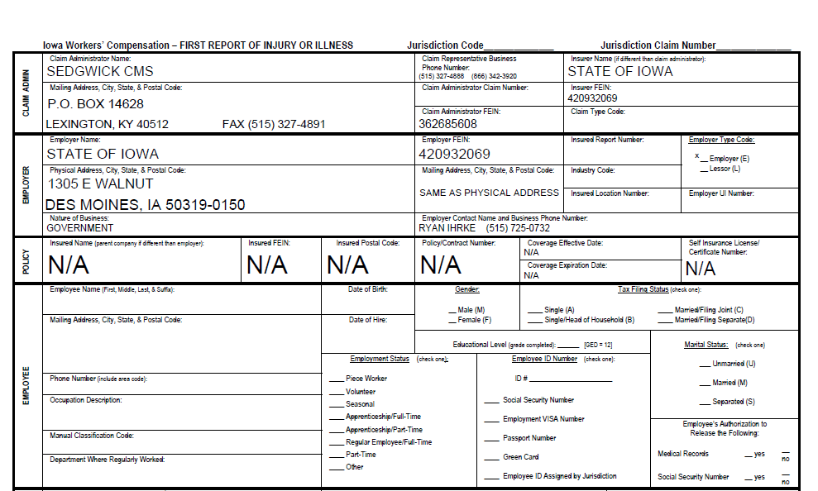
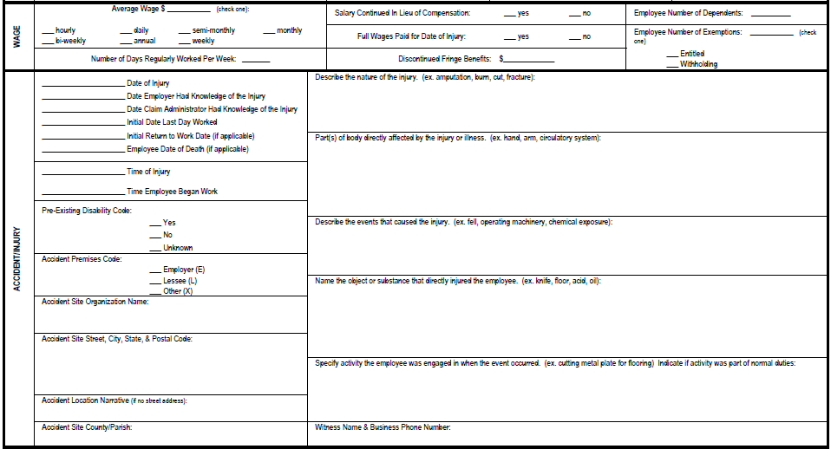
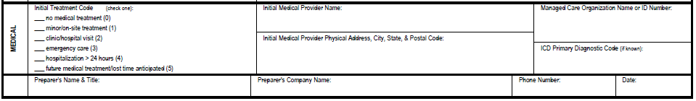
Exhibit 4.1 -- Workers’ Compensation – First Report of Injury or Illness
EXAMPLE
Click here to download the most current form: First Report of Injury or Illness

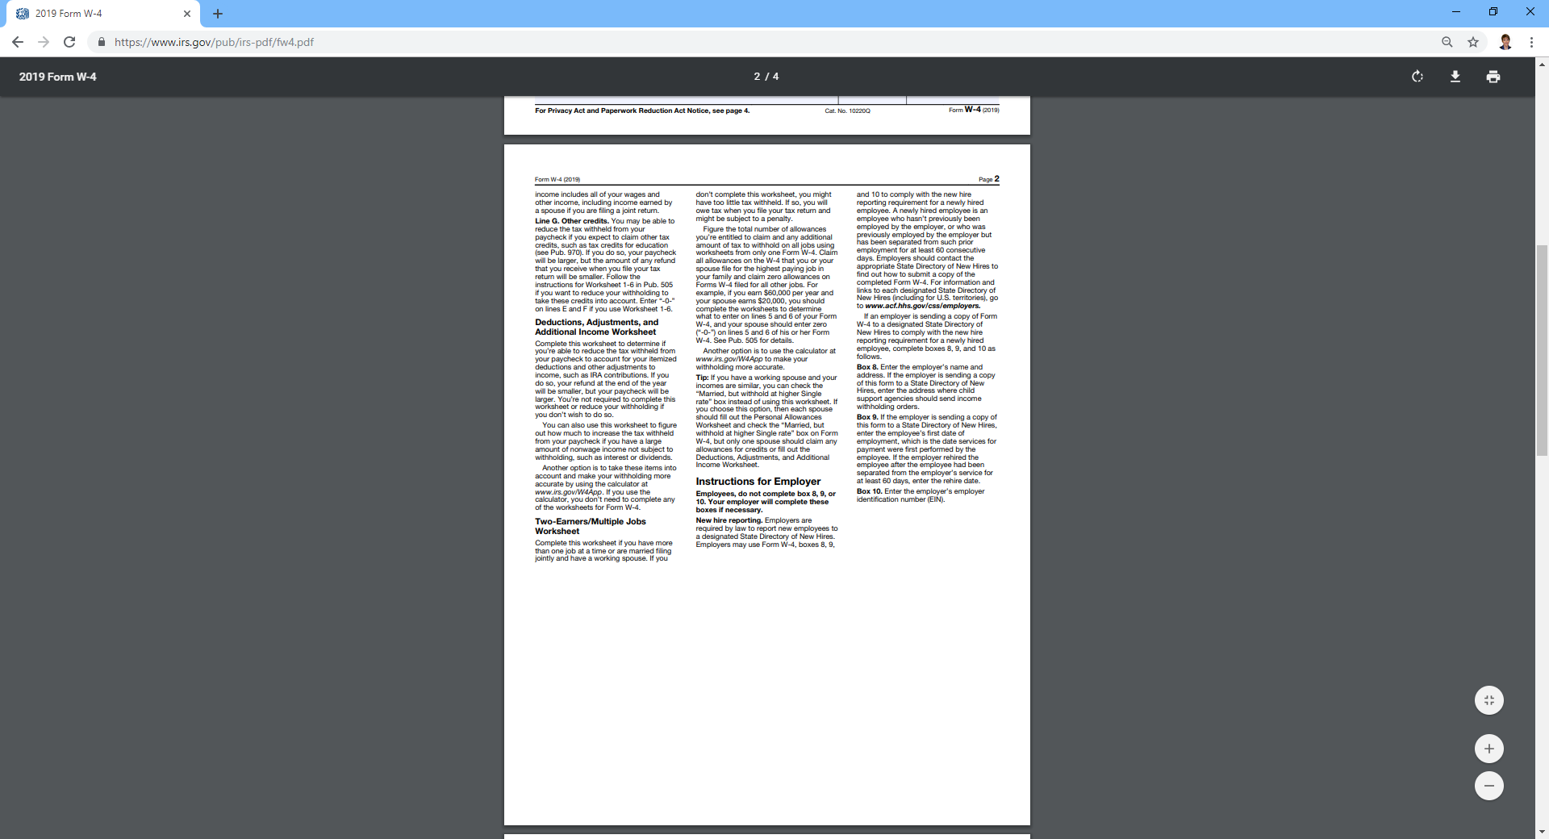
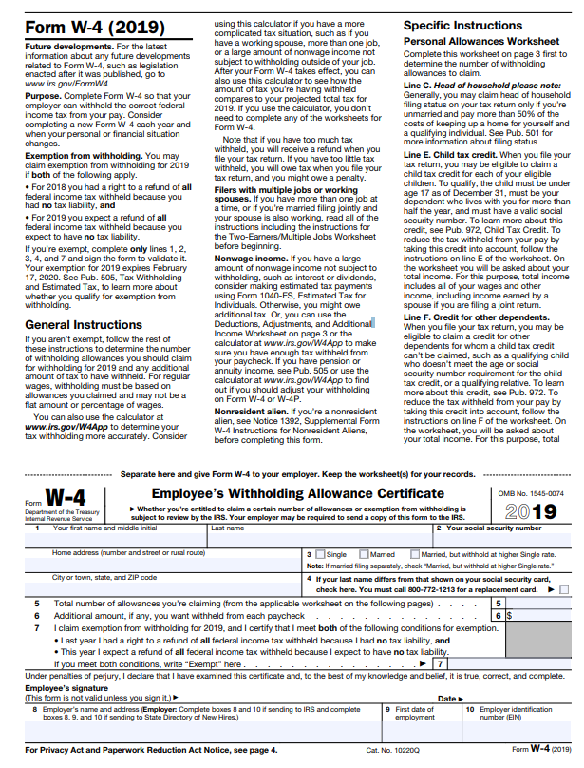
Exhibit 4.2 -- Federal W-4 Form
EXAMPLE
Click here to download the most current form: IRS About Form W-4, Employee's withholding
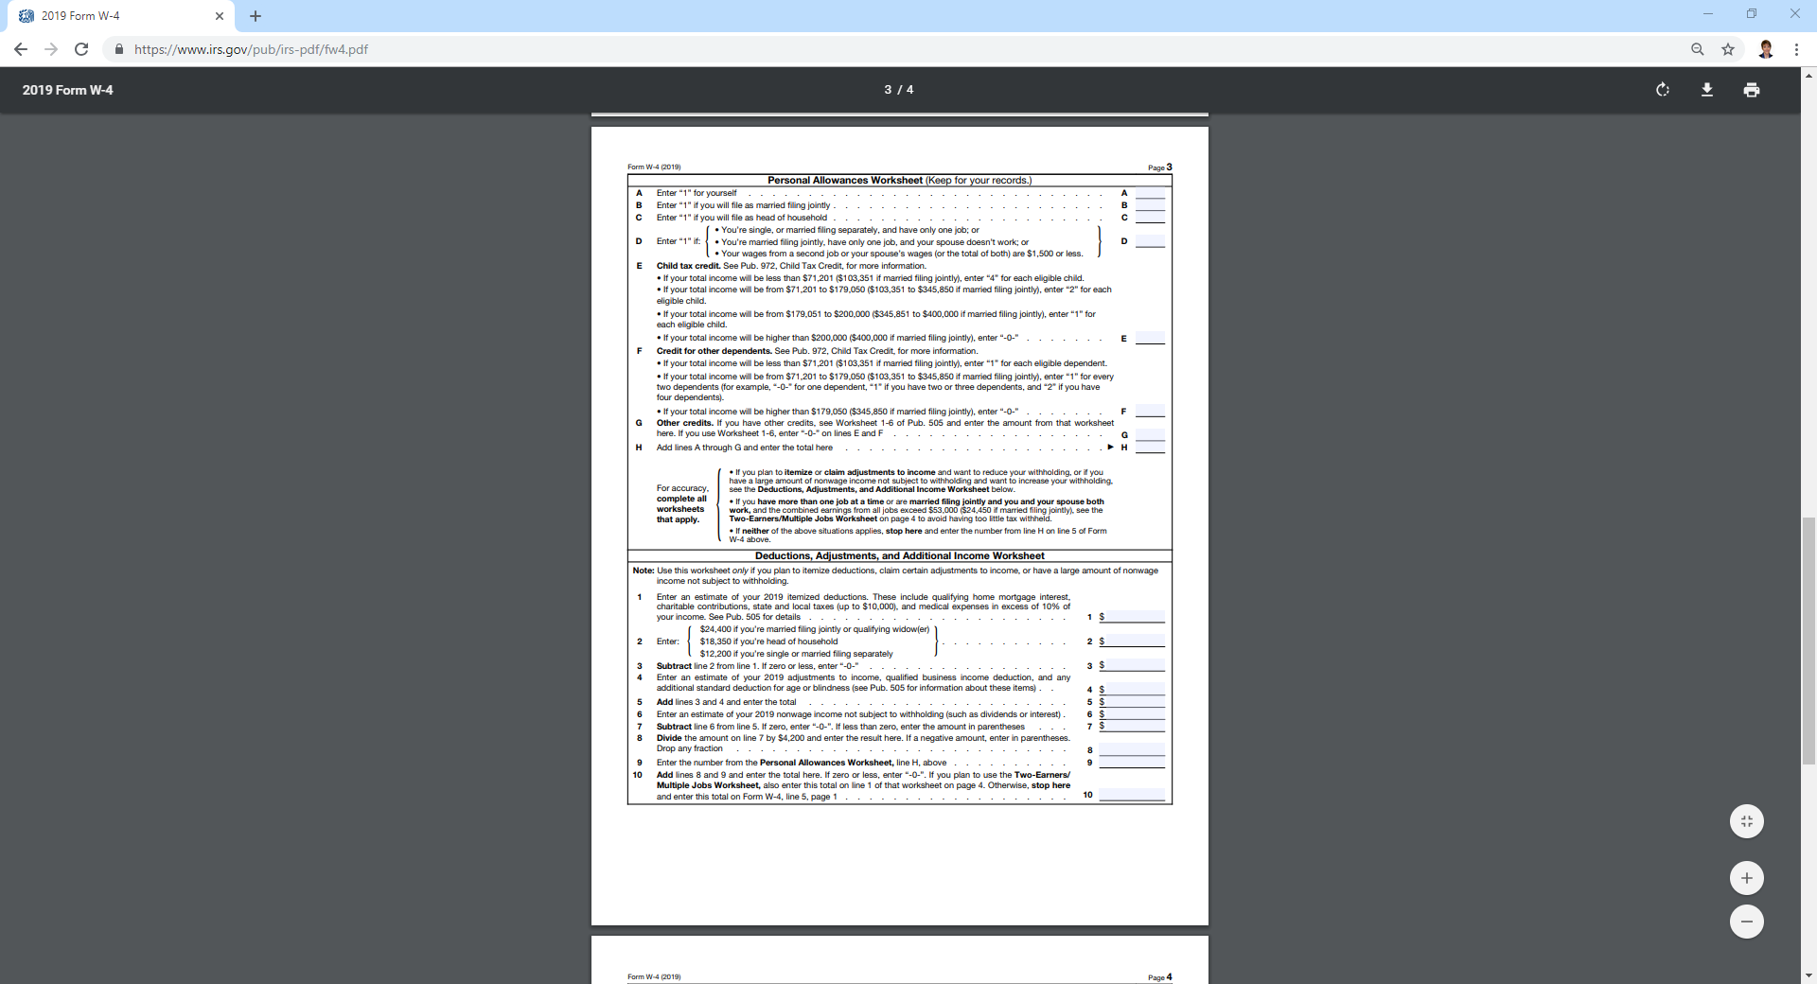
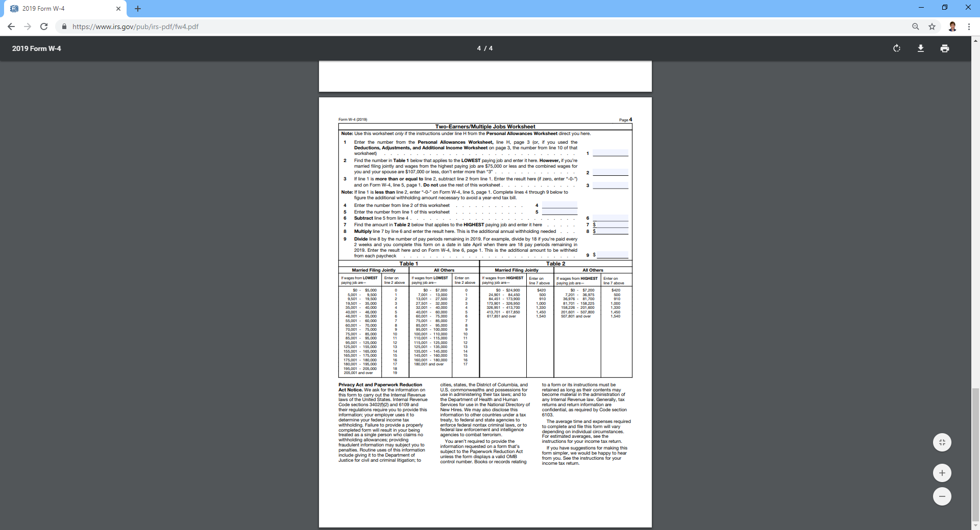
Exhibit 4.2 -- Federal W-4 Form continued
EXAMPLE
Be sure to download the most current form at
IA W-4 Employee's Withholding (44-019)

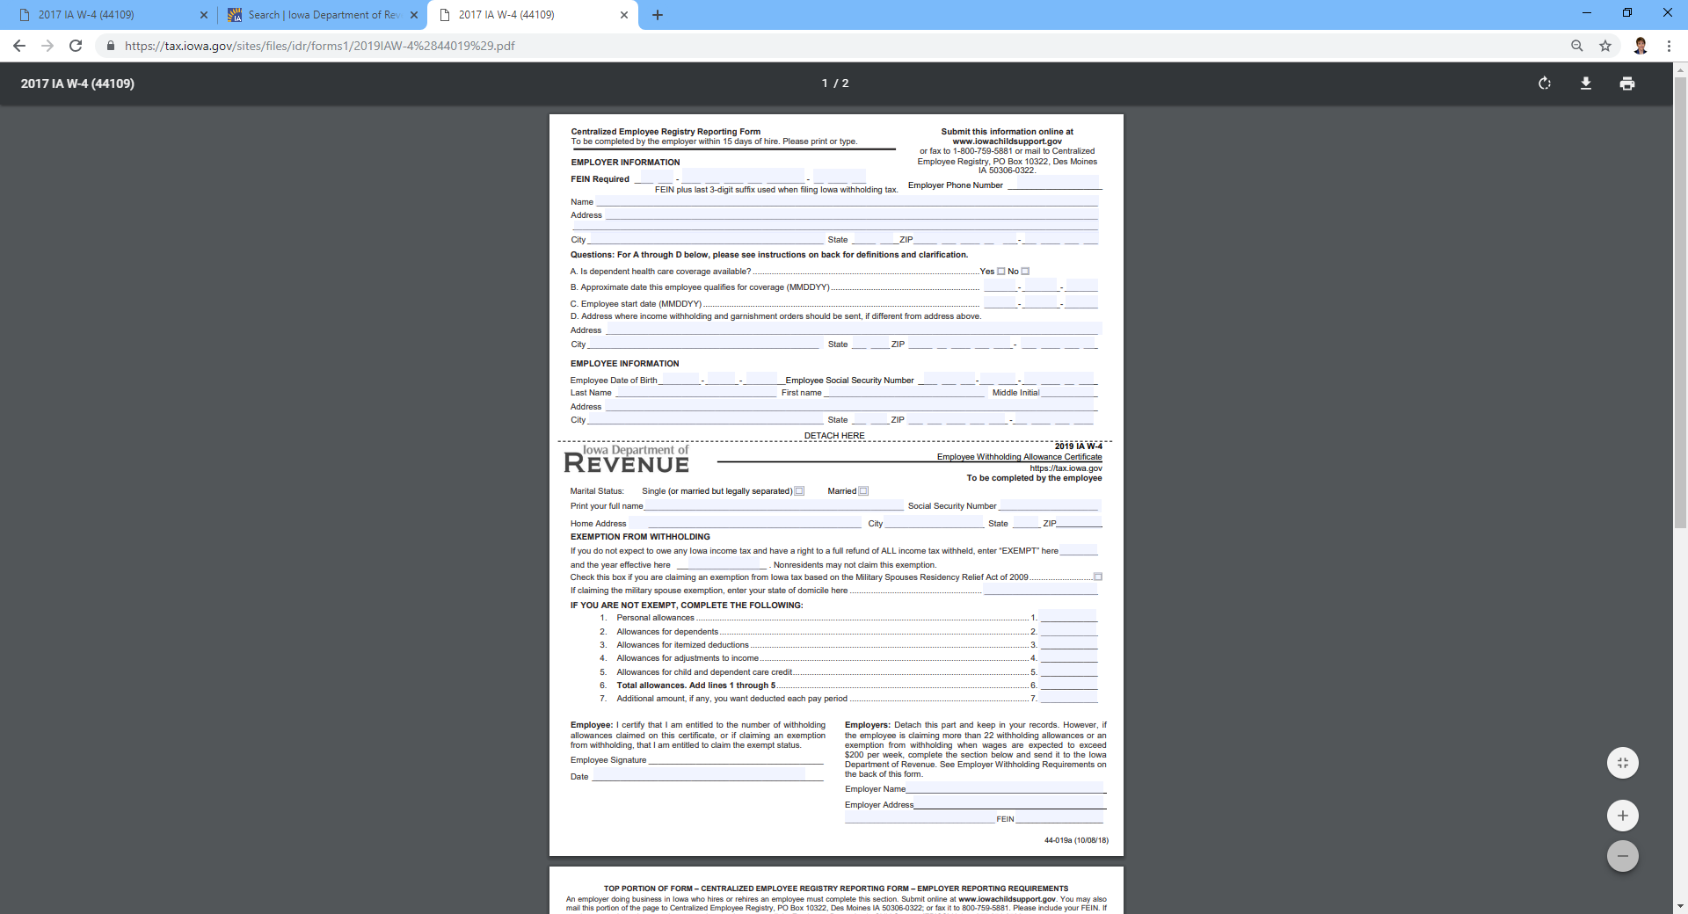
Exhibit 4.3 -- Iowa W-4 Form
EXAMPLE

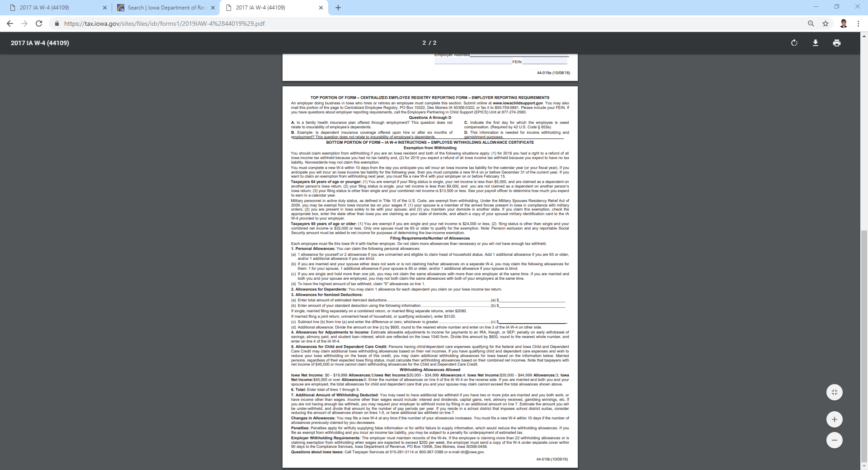
Exhibit 4.3 -- Iowa W-4 Form continued
EXAMPLE

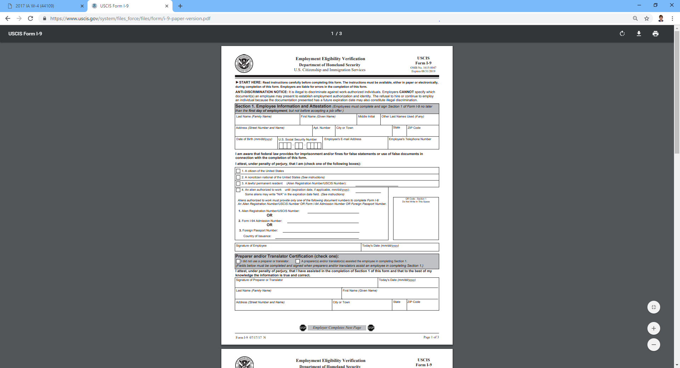
Exhibit 4.4 -- Employment Eligibility Verification
Be sure to download the most current form at I-9, Employment Eligibility Verification

EXAMPLE

Exhibit 4.4 -- Employment Eligibility Verification continued
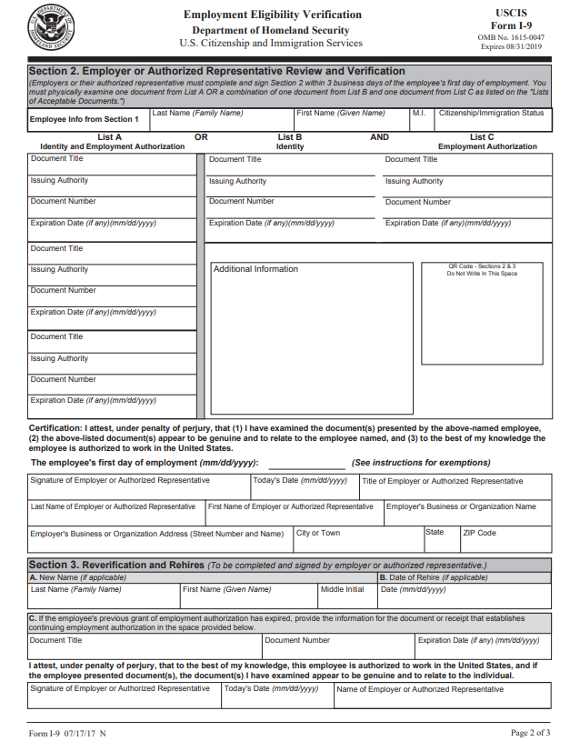
EXAMPLE

Exhibit 4.4 -- Employment Eligibility Verification continued

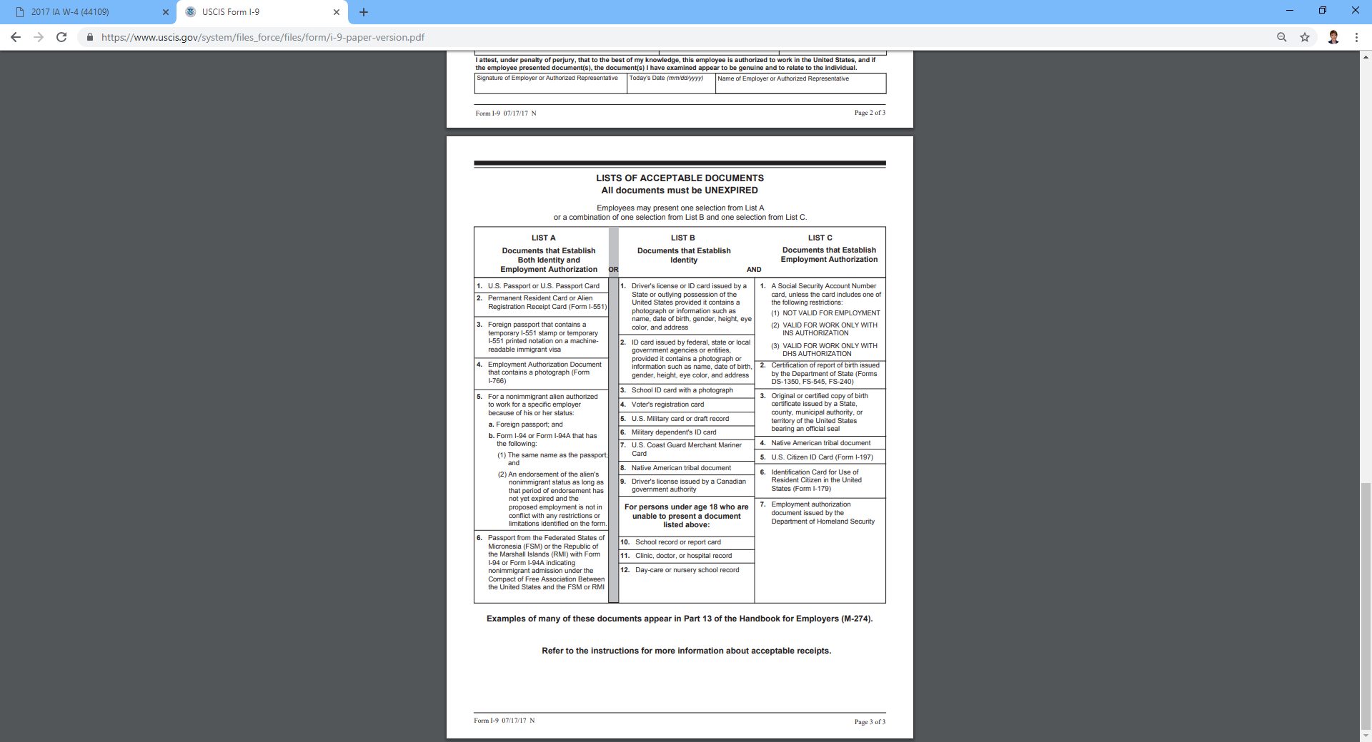
EXAMPLE

Exhibit 4.5 -- Checklist for Wages, Taxes, Benefits and Leave

ITEM COMPLETED

- Determine wages

- Make determinations for wage increases when appropriate

- Mandatory Leave
Court Duty/Jury Duty
Leave of Absence for Candidacy and Public Service _________
Military Leave
Workers Compensation

- Optional Benefits
Paid Time Off (PTO)
Insurance

- Review Overtime Policy and Emergency Closings

- Complete Forms for District Payroll Required Withholdings
Federal Withholding
State Withholding
Social Security Medicare
IPERS
Unemployment
Employment Eligibility Verification (I-9) __________

Chapter 5 - Employment

New Employee Package
Commissioners should ensure that a new employee package is provided to the new employee. (See Exhibit 5.1, New Employee Package.) New employees should be encouraged to ask questions about these topics.

Orientation
New employee orientation should be provided BY THE DESIGNATED COMMISSIONER LIAISON ON THE EMPLOYEE’S START DATE. In addition to the employee information detailed in Exhibit 5.1, New Employee Package, it should include the following:

Introduction of local staff
Outline of the Core Conservation Partnership
Work schedule
Pay period calendar
Information on the field office including work stations and equipment, parking, restrooms, food facilities, security procedures, etc.
Travel and training procedures
Additional written work rules, policies and procedures not included in the Employee Handbook

Contracts
Because of employee/employer relationships and requirements, districts should avoid written contracts as a type of employment. If a district wants to enter into a written contract, they should seek advice from the Conservation Districts of Iowa or the Division of Soil Conservation and Water Quality. A review of all written contracts should be done by the Attorney General’s office before your district enters into one.

District Organization and Responsibilities
Districts work in close partnership with many federal, state and local agencies and organizations. Review the Mutual Agreement and Cooperative Working Agreement with the District Employee. Copies of these agreements can be found in the District offices, NRCS state office or IDAL-DSCWQ office.

Supervision and Hierarchy
District Employees are hired, paid, disciplined, and, when appropriate, fired by the District Commissioners. Commissioners set District Employee job expectations, work schedule, wages and benefits. The NRCS DC is responsible for coordination of the day-to-day activities of District Employees to accomplish job expectations. These directions are explained in the Cooperative Working Agreement. Please refer to the Core Conservation Partnership diagram, Exhibit 5.4. If an employee has concerns or questions not resolved by the NRCS DC or if the issue is NRCS related they should contact their commissioner liaison.

Review Job Expectations
The District and employee should review the Position Description and Duties and Standards, developed in Chapter 2. It should be understood what the job will require and what goals should be met by the employee. These documents should be signed by the employee as an acknowledgement, and a copy should be maintained in the individual employee personnel file. Please refer to the examples provided in Chapter 2. Performance duties and standards must be clearly stated for the Performance Evaluation, Exhibit 6.1.

Hours of Work/Time Reporting Document/Pay Period
The District Commissioners should set the starting time and ending time for District Employees. Remember that someone should be coordinating the day-to-day activities of a District Employee at all times A typical work day is eight (8) hours with two 15 minutes breaks, one mid-morning and one mid-afternoon, with a half hour or one hour lunch. A District Employee should not work more than 40 hours per week. (See Chapter 4, Wages, Taxes, Benefits and Leave – Overtime

Please refer to the sample Time Reporting Document, Exhibit 5.5. There is also a copy of an Application for Leave, Exhibit 5.6. It is suggested that districts offer Paid Time Off (PTO) as a form of leave, as outlined in Chapter 4. Districts should establish a pay period for all District Employees that is consistent with the time reporting document. Most pay periods are biweekly.

Equipment and Workstation
NRCS will provide access to equipment for each District Employee according to the Cooperative Working Agreement, which will allow the employee to carry out the job expectations. An employee should not use or allow the use of district, state or federal property of any kind for other than officially approved activities. No government equipment of any kind can be used for lobbying purposes.

Before a non-federal employee can gain access to USDA buildings, it is necessary for the NRCS to complete a background check and have the employee obtain a LincPass card. In addition there is other appropriate paperwork needing completion. Contact your local NRCS Administrative Management Assistant to verify current procedures.

All District Employees working under a cooperative arrangement with NRCS may drive NRCS vehicles when they are performing NRCS work in a government vehicle; however, they must pass the Defensive Driving Course and complete the Safety and Health Request for Authorization to Operate Government Vehicle, Exhibit 5.3 and submit it to the District Conservationist. It should be clearly stated that it is unacceptable for an employee to operate a government vehicle while under the influence of alcohol or drugs. The employee could be held personally liable if driving and acting outside the scope of his employment, and the District could be held liable as the employer.

The employee in a position that requires a valid state driver’s license should be advised that if the employee’s driver’s license is suspended, revoked, or cancelled or the employee is otherwise disqualified from operating a motor vehicle, the employee must notify the employer before the end of the business day following the date the employee received notice of the loss of driving privileges. If this occurs, the employee is unable to perform assigned duties, will no longer meet the minimum qualification requirements for the position, and shall be terminated.

A District Employee is bound by the same rules for computer usage as those that apply to state and federal employees. All activities on the computer system and network may be monitored, intercepted, recorded, read, copied, or captured in any manner and disclosed in any manner, by authorized personnel. There is no right of privacy in the system. System personnel may give to law enforcement officials any potential evidence of crime found on USDA computer systems. Use of the system by any user, authorized or unauthorized, constitutes consent to this monitoring, interception, recording, reading, copying or capturing and disclosure. Report unauthorized use to a USDA information systems security officer. The electronic tools referred to in this section should not be used to conduct personal business. Be aware of disciplinary action that will follow computer use for pornographic, gambling, or sites that promote hate or ethnic violence or civil rights violations. Do not send personal e-mails for questionable purposes such as so called ethnic humor. Personal use should never interfere with individual duties and the ongoing operations of the office. The USDA, State of Iowa and the District have a zero tolerance policy on visiting sites that are or could be child pornography. Any suspected incidents will be investigated for potential prosecution.

Travel and Training
All training and travel should be job related and are at the discretion of the District Commissioners. Prior approval must be requested in written formwith the agenda and estimated cost for pre-approved by the District. See Exhibit 5.7, Request to Attend Training Sessions. Detailed receipts must be submitted for reimbursement.

Tort Liability
District Employees, as agents of the State of Iowa, are covered under the State’s tort liability law as long as they are carrying out their official duties with due care and in good faith. Tort claims are civil claims that are brought on allegations of wrongful death or injury to a person or damage to property. Law suits are typically based on negligence, breach of duty or nuisance. Providing employees are acting within the limits of their duties, the State Attorney General’s office will defend them against suits.

Contact the IDALS-DSCWQ whenever the District is unsure about potential liability, and the IDALS-DSCWQ will initiate contact with the Attorney General’s office.

Bonding
Effective July 1, 2016 SWCDs are covered under the state’s blanket bond policy. The applicable costs associated with the policy premiums are covered by IDALS. This bond coverage satisfies the requirements in Chapter 161A.6 of the Iowa Code. Contact IDALS-DSCWQ for general provisions and a copy of the policy.

Identification
It would be helpful for District Staff to get and wear name badges so when they are in the field they can be easily identified by landowners and authorities. High visibility attire may be beneficial as well when working near busy roads.

Employment Termination
When a District Employee leaves employment for whatever reason, it is a good idea to have them complete an Exit Interview, Exhibit 5.9. The District should also complete a Record of Exit, Exhibit 5.10, and send an exit letter to the employee leaving. Please refer to the examples provided as Exit Letter, Exhibit 5.11, and Sample Letter of Termination, Exhibit 8.5. Copies of these letters should be provided to the District Conservationist so that computer log-ins, etc., can be disabled.

Exhibit 5.1 – New Employee Package
Employee Name
District Employment Date
Supervisor Name Day-to-day Coordinator Name
Hourly Wage Performance Review Date
Work Hours PTO Starting Accrual Rate
Full Time Hours per week Part Time Hours per week

Listed below are the items that should be in the New Employee Packet and reviewed with the employee.
Employment Eligibility Verification (Form I-9), Exhibit 4.4
(must be filled out during orientation)
Confidential Emergency Information, Exhibit 5.2
(fill out during orientation)
Example of Time Reporting Document, Exhibit 5.5
Example of Application for Leave, Exhibit 5.6
Federal and State W-4’s, Exhibits 4.2 and 4.3
(must be returned within two days)
Position Description
Pay increase eligibility dates and performance evaluation criteria
Request for Authorization to Operate Government Vehicle, Exhibit 5.3

New Affiliate, Contact your local NRCS Administrative Management Assistant to verify procedure.

Example of Request to Attend Training Sessions, Exhibit 5.7
Employee Handbook
Acknowledgement of Receipt of Employee Handbook, Exhibit 5.8
Statement of Eligibility for Family and Medical Leave Act of 1993 (FMLA)
Review Process for on-the-job injuries, Exhibit 4.1

Exhibit 5.2 – Employee Confidential Emergency Information
VOLUNTARY
EMPLOYEE CONFIDENTIAL EMERGENCY INFORMATION
Completing this information form is VOLUNTARY in an effort to assist you if you are unable to communicate for yourself.

Employee Name
Home Address

In case of emergency, contact:
Primary Contact:
Relationship to employee:
Home Phone (_____) Work Phone (_____) ___________________

Secondary Contact:
Relationship to employee:
Home Phone (_____) Work Phone (_____) ___________________

Name(s) of person(s) living at your residence (besides yourself)

Which hospital do you prefer?
Primary Doctor to call if we cannot reach a family member:
Name of Physician
Phone ( )

Additional Information:
______________________________________________________________________________________________________________________________________________________________________________

Employee Signature

Date

Exhibit 5.3 – Request for Authorization to Operate Government Vehicle
Authorization to Operate Government Vehicle
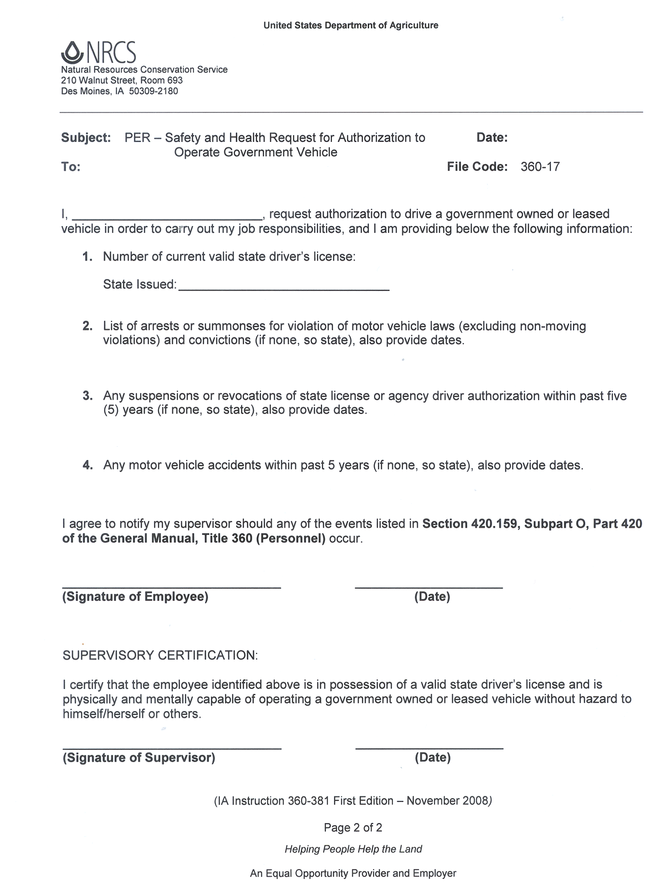
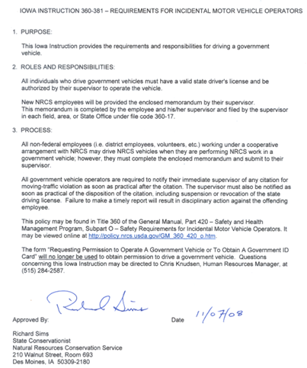

Exhibit 5.4 – Core Conservation Partnership
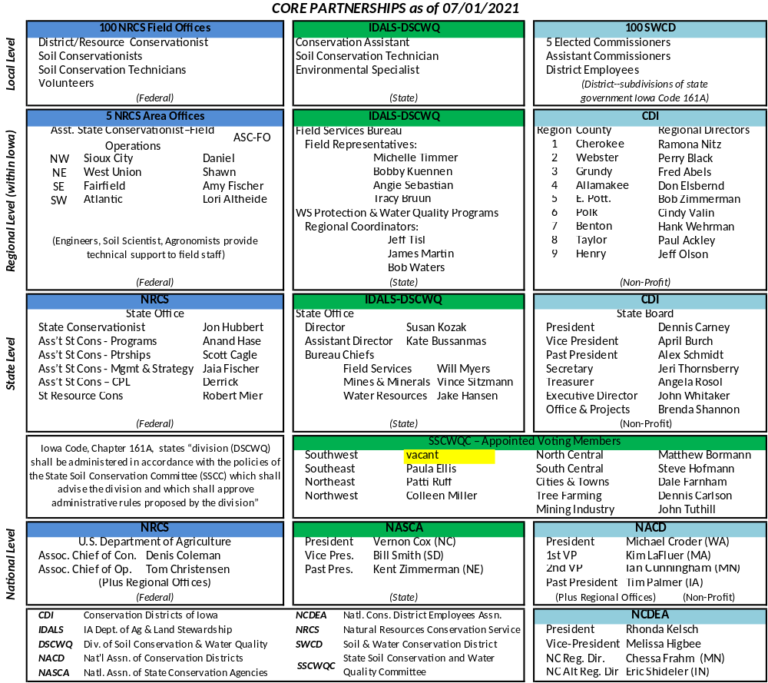

Exhibit 5.5 – Time Reporting Document
Time Reporting Document

Soil and Water Conservation District

Employee Name
Week 1
Day |  | Date | Hours Worked | PTO | Funding Source
Monday
Tuesday
Wednesday
Thursday
Friday
Sub-total
May not exceed 40 hours
Week 2
Day |  | Date | Hours Worked | PTO | Funding Source
Monday
Tuesday
Wednesday
Thursday
Friday
Sub-total
May not exceed 40 hours
 |  |  | Hours Worked | PTO |  | Total ALL hours
Pay Period Totals
May not exceed 80 hours

Employee’s Signature: ____________________________________ _____________
Date
Commissioner’s Signature: _________________________________ _____________
Date

Exhibit 5.6 – Application for Leave

APPLICATION FOR LEAVE |  |  |  |  |  |  | Date Submitted
Last Name |  |  | First  Error: Reference source not found |  | Middle |  | District
No. of hours requested | Beginning |  |  | Ending
No. of hours requested | Time | Date  MM-DD-YYYY |  | Time |  | Date  MM-DD-YYYY

Employee Signature Date

Leave Request Approved Disapproved

Commissioner Signature Date

Exhibit 5.7 – Request to Attend Training Sessions
Request to attend training
The following information must be submitted to the SWCD and respective Agency at least three weeks before the pre-registration deadline. It is the responsibility of the employee making the request to submit this information. Information submitted by telephone will not be accepted.

Name: NAME SWCD: DISTRICT

Date of Request: DATE OF REQUEST

- Attach copy of the agenda and registration form to this form.

- Reason for attending:

- Has training need been identified on Performance Plan and Evaluation?

- Time and date of leaving and returning to your assigned work location:

- Direct and indirect costs
A. Registration costs $ (Registration deadline: )
B. Transportation Costs $
C. Lodging costs $
D. Meal costs $
E. Miscellaneous costs $

- Funding Source
A. Cost Center Number State Federal Other

TOTAL COSTS $
----------------------------------------------------------------------------------------------------------------
FOR OFFICE USE ONLY

Training offered by: IDOP Private Contractor

How is training relevant to the employee’s current duties?

Conference fee directly paid: YES / NO

Approval or denial statement:

SWCD: ____________________________ Date_________ Approved / Denied
NRCS: ____________________________ Date_________ Approved / Denied
IDALS: ____________________________ Date_________ Approved / Denied

Exhibit 5.8 – Acknowledgement of Receipt of Employee Handbook

(Insert your County Name) SOIL AND WATER CONSERVATION DISTRICT

Acknowledgement of Receipt

Of

Employee Handbook

I, (print employee’s name) acknowledge that I have received the (insert your SWCD name) Soil and Water Conservation District Employee Handbook. I understand this handbook is not intended to cover every situation which may arise during my employment, but is simply a general guide to the policies, practices, and benefits of the District. I am aware that I am expected to read and follow the rules and conditions set forth in this handbook. I am also aware that I am expected to read and be familiar with any future updates to the information contained in this handbook. I understand that the handbook is not a contract of employment and should not be deemed as such, and that I am employed at will. I understand that district employment is based on the availability of funds designated for this purpose.

In addition, I acknowledge that I have received the District’s New Employee Package including policies on Equal Employment Opportunity and Anti-Discrimination, Drug Free Workplace and Substance Abuse, Tobacco Use, Social Media, Violence Free Workplace, Harassment and Sexual Harassment, and that I have been directed to read these documents and was offered an opportunity to ask questions about the contents. Further questions regarding this material may be directed to the District Commissioners.

Employee Signature Date

District Commissioner Signature Date
Distribution of this form after completion:
Employee
Personnel file

Exhibit 5.9 – Exit Interview
EXIT INTERVIEW

A face to face interview with an employee that has resigned could be a great opportunity for feedback. Some businesses do not recommend it, saying useful and candid information is seldom obtained by interviews especially if the employee may be hostile or vindictive toward management authority or other employees. They prefer to use a questionnaire. We have provided a sample of what could be used as either an exit interview or questionnaire.

Employee District

Date of Employment Date of Separation

To help us improve the quality of the District’s services and to improve employee job satisfaction and working condition, we would like you to complete this questionnaire. Your candid remarks are vital. Responses will be shared only with the commissioners unless you request otherwise.

- Do you have another job? Yes No If so, where?

- Why did you decide to seek other employment?

- Would you consider reemployment with the District? Yes No If no, why not?

- Were you given complete and accurate information regarding job duties prior to your acceptance of your job with this district? Yes No Explain

- Were you provided the necessary orientation, training and tools to successfully carry out your job duties here? Yes No Explain:

- Do you feel supervision given you was effective and impartial? Yes No Explain:

- What did you find to be most enjoyable about your job?

- What did you like the least or find most frustrating about your job?

- What changes would have made your job more desirable?

EXIT INTERVIEW (Page 2 of 2)

- What changes would have improved the performance of your job?

- Were your working conditions satisfactory? Yes No Explain:

- Additional comments about the field office or about the District in general:

- Would you like a copy of this given to anyone? Yes No Name(s)

- Additional comments:

Employee Signature Date

Employer or Designee Signature Date

Other Sample Questions:

- Tell us why you resigned.
- If you had the power to change your job, what would you do?
- Were there any hazardous duties or safety concerns associated with your job?
- Do you have any suggestions to improve the organization?
- Is there anything you want to tell us that we should know?
- Did you have all the right tools to do your job?
- Did you feel we supported you in the performance of your job?
- Do you have any suggestions for management?

Distribution: Personnel file
Per #13 above

Exhibit 5.10 – Record of Exit
SAMPLE RECORD OF EXIT
1. NAME (last, first, middle) |  |  | 2. TERMINATION DATE  ______-______-______  mo day yr
3. POSITION TITLE | 4. FORWARDING ADDRESS (For W-2)  _______________________________________________  Number Street City State Zip
5. REASON FOR TERMINATION (check only those items that apply)

Voluntary (the employee is the initiating party): Attach letter of resignation from employee explaining reasons.  Date Supervisor Notified: ______________________ |  | Involuntary (the employer is the initiating party): Attach memo from supervisor explaining reasons.  Date Employee Notified: ______________________
Voluntary Quit:   transportation problem   homemaking   death in family   health   moving from area: reason ______________   military service   attend school   going into own business   declined to give reason for quitting   failed to return from leave of absence on agreed date   dissatisfied with hours, job, pay, benefits, etc.   new job: new employer _____________________________________  starting date ___________ pay rate _________  position ____________________   early retirement - (own decision)   other __________________________________________  __________________________________________ |  | Layoff:   lack of work   lack of funds   job or project eliminated   end of temporary employment   other  Released:   failed to meet job requirements  Discharged:   for misconduct  Resigned:   in lieu of involuntary termination  Retirement:   normal   in lieu of involuntary termination
6. COOPERATION AND CONDUCT   Excellent  Good  Average  Fair  Poor |  | 7. JOB KNOWLEDGE AND SKILL   Excellent  Good  Average  Fair  Poor
8. OVERALL PERFORMANCE IN LATEST JOB   Excellent  Good  Average  Fair  Poor |  | 9. RECOMMENDED FOR REHIRE   Yes  No
10. COMMENTS AND OBSERVATIONS

______________________________________________________
Signature of Commissioner Date

Exhibit 5.11 – Exit Letter

(SWCD Letterhead)

DATE

NAME OF PERSON LEAVING EMPLOYMENT
ADDRESS OF PERSON LEAVING EMPLOYMENT
CITY, STATE AND ZIP OF PERSON LEAVING EMPLOYMENT

Dear NAME OF PERSON LEAVING EMPLOYMENT,

This is to notify you that your employment with DISTRICT NAME Soil and Water Conservation District will end effective DATE EMPLOYMENT ENDED.

On behalf of the Commissioners, I thank you for your service to the District and wish you the best of luck.

Sincerely,

NAME OF CHAIRPERSON, Chair
DISTRICT NAME Soil and Water Conservation District

cc: Personnel File
District Conservationist

The DISTRICT NAME SWCD is an equal opportunity employer and provider.

Exhibit 5.12 – Checklist for Employment

ITEM COMPLETED

- Employee orientation done at the start of employment.
- Employee wage and benefits were reviewed.
- Forms are completed for employment.
- Employee handbook and work rules were reviewed.
- Employee hours of work and PTO were reviewed.
- Review job description and standards expected.
- Review who supervises and who coordinates daily activities.
- Review hierarchy.
- Review of workstation and equipment, including vehicle use.
- Was an exit interview or termination letter used?
- All-important employment documents should be in the file.

Chapter 6 - Evaluation
There should be a time when a District Commissioner, the District Conservationist and the employee get together for the specific purpose of reviewing performance. This should be a private session, not part of a board meeting. Although evaluation of an employee's performance is a continuing process, a formal discussion with the employee should take place at least once a year. The evaluation should be a culmination of numerous informal observations, checks and discussions made throughout the year.

The following benefits may be realized from a formal performance evaluation system.

- Individual performance will improve.
- Supervisor-employee relationships will improve.
- Employee accomplishments and good work will be recognized.
- Personnel actions, such as pay increases, promotions, removals, and re-hires, will be based on sound, objective criteria and will be documented.
- Employees and supervisors will be more aware of job requirements and needed changes in job duties.
- Employees will be more aware of their supervisor's judgment of their performance.
- Training needs will be identified.

A formal discussion with the employee should take place just prior to, and be the basis for, decisions made regarding merit salary increases. A formal review of an employee's performance should also take place at the end of any probationary period of employment. An example Performance Evaluation is included in this chapter as Exhibit 6.1.

The Importance of Objectivity
In the past, many performance evaluation systems contained such items to be appraised as initiative, leadership, loyalty, and dependability. Although we all want loyal and dependable people who are leaders and show initiative, there is an inherent difficulty in including these characteristics in an evaluation system; it is difficult to be objective.

This is not to say that leadership, loyalty, initiative, and other personal traits are not important and should not be considered. However, subjective measurements that tell what a person is or knows should not take the place of objective measurements that tell what a person does.

Steps in the Formal Evaluation
Prepare for the discussion. Effective evaluations don't just happen - they are planned. Gather facts, review the job description and performance standards, and decide what you want to accomplish.

Pick a good time and place. Arrange to hold the discussion where it will not be interrupted. Allow ample time for the discussion. Pick a time when both you and the employee can be relaxed. This should be a private session, not during a board meeting.

Open the discussion in a friendly and permissive manner. Tailor the approach to each individual. Let the discussion develop naturally.

Explain the purpose of the talk. Once the meeting has been opened on a positive, friendly note, state clearly the purpose of the talk.

Ask the employee to review their responsibilities. It is not unusual that clarity is lacking concerning some aspects of the job. Ask the employee to give a general review of their major assignments. Ask which assignment they consider the most important, which efforts have produced successes, and where problems have appeared. Encourage the employee to talk and don't interrupt unnecessarily.

Discuss each job duty. Review the performance of each job duty with the employee and let them know how well they performed each duty.

Jointly develop the next year's performance standards. This gets the employee involved and promotes mutual understanding. Make any needed adjustments in duties and responsibilities.

Jointly develop plans for improvement. Discuss with the employee ways in which performance can be improved. Discuss areas where additional training is needed.

Guidelines for Evaluating Employee Job Performance
Don't rely on gimmicks. Even the best performance evaluation form won't relieve the supervisor of the responsibility of making decisions about an employee's competence. The best way to judge competence is to work with the employee day by day, to make observations during moments of routine, and stress in a variety of assignments.

Admonish when necessary. Tell an employee when they have done well and when they have not. They won't resent correction handled in a natural manner. However, it is hard for both supervisor and the employee if this is lumped all together in a single, grueling session held once or twice a year.

Be self-critical. Before an employee is admonished for inadequate work, ask yourself frankly, "Has leadership contributed to this deficiency in any way?" "Was too much expected?" "Did the employee understand the duty?" "Did the employee have proper training to do the job?" "Is the criticism absolutely fair, or is it influenced by bias?" Objectivity enables discussion of the employee's mistakes to be constructive. Willingness of the supervisor to accept accountability for mistakes will make the employee more willing to shoulder responsibility.

Make sure the employee has the same understanding of the job that the supervisor has. An employee's job performance cannot be judged fairly if they have not fully understood the duties of the position. Let the employee talk. It may be found that the employee was unaware of responsibility for certain job duties for which the supervisor claimed neglect.

Get down to cases. Vague generalities don't work. Be specific. Explain in precise language where the employee is falling short, and what can be done to correct mistakes. Make sure the employee understands precisely what standards he is expected to meet.

Criticize the work, not the person. Avoid being personal when discussing an employee's job performance. There are certain exceptions to this advice, e.g. if the attitude of the employee is affecting their job competence.

Don't laugh it off. Some supervisors try to hide criticism behind humor. This is a mistake. If confrontation is necessary to improve performance and competence then the seriousness must be conveyed as well. An employee's competence at the job is very serious both to the employee and to the supervisor. Supervisors who are honest and frank with constructive criticism will often earn the respect of their employees.

Comment on improvements. If an employee corrects a shortcoming that has been criticized, comment on the improvement. This will encourage the employee to continue in excellence and improve the response to future corrections.

Don't be a debater. The supervisor is the final judge of an employee's job performance. This doesn't mean to cut off all discussion. Let the employee state a point of view, and if correct, say so. Don't permit the discussion to turn into an argument.

Don't compare. Comparisons are not recommended. This is especially true in discussing job performance. An employee may be willing to accept criticism of deficiencies, but they may be resentful if another individual is pointed out as an example to be followed.

Emphasize strong points. The skillful leader plays up the strength of subordinates. It's better for a worker to develop special talents and skills than to spend the entire time trying to correct weaknesses. Point out an employee's deficiencies and help try to minimize them, but keep things in balance. If concentration is entirely on the negative, little will be accomplished in developing the positive.

A checklist for performance evaluation is included in this chapter as Exhibit 6.2.

Analyzing Poor Performance
Many Districts have had to face the problem of an employee performing at an unacceptable level. Such a situation is the true test of a good supervisor because the way in which the problem is handled may very well affect the life of the employee. The causes of poor performance are too numerous to detail, but they can be grouped into three categories: the employee, the supervisor or the situation. Determining the exact cause of poor performance and taking appropriate action are very important in maintaining the efficiency of district operations.

The following is a very general discussion of the causes of poor performance.

The employee. Outside forces, such as financial pressures, family or health problems can be responsible for poor performance. The cause should be determined and professional help sought if necessary. Perhaps the employee is careless or negligent. Perhaps the job itself is beyond the current capabilities of the employee. In such a case, additional training may be the answer.

The supervisor. Has the supervisor upheld their responsibility to the employee? Did the supervisor adequately determine training needs? Has the supervisor maintained a periodic check of the employee's performance and suggested improvements? Have the requirements of the position been adequately explained to the employee?

The situation. Do conditions exist on the job that preclude acceptable performance or are beyond the control of the employee? Were standards set too high? Does the job hold a challenge for the employee?

Regardless of the cause for poor performance, the reason should be determined and appropriate action taken.

Employee Response
Allow the employee to respond in writing to an evaluation. This response would become part of the employee’s personnel records.

Exhibit 6.1 – Performance Evaluation
PERFORMANCE EVALUATION (Page 1 of 3)

Employee's Name District

Employee's Title Period Covered to

PART 1

Performance Duties and Standards | Performance Rating
PERFORMANCE DUTIES - Main jobs or tasks to be accomplished  STANDARDS - Conditions that will exist or the specific work items that will be accomplished when the employee is performing the job or task satisfactorily. | EVALUATION NOTES | E - excellent  S - satisfactory  I - needs improvement  (enter 1)
DUTY: (From Job Description, Exhibits 2.1 thru 2.4.)  Type correspondence, newsletters & reports | Is quick, efficient and timely |  | E
STANDARD: (List standard developed according to job description.)  No typographical errors, grammatically correct | Rarely has typos, grammar always correct |  | S

PERFORMANCE EVALUATION (Page 2 of 3)

Employee's Name District

Employee's Title Period Covered to

GENERAL APPRAISAL OF EMPLOYEE PERFORMANCE
COMPLETE ITEMS BELOW FOR ALL EMPLOYEES  (highlight items needing improvement) |  | E - excellent  S - satisfactory  I - needs improvement  (enter 1)
Job Knowledge: | Knowledge of duties and responsibilities of position
Productivity: | Amount of work generated and completed successfully as compared to amount of work expected of position
Quality: | Correctness, completeness, accuracy, and economy of work - overall quality
Initiative: | Self-motivation - amount of direction required - seeks improved methods and techniques - consistence in trying to do better - responds to need for extra effort
Use of Time: | Uses available time wisely - is punctual in reporting to work - absenteeism - accomplishes required work on or ahead of schedule
Planning: | Plans and organizes own work - anticipates and prepares for future requirements - establishes logical priorities - maintains control of workloads
Follow-up: | Finishes all projects begun -leaves no loose ends - ensures assignments are completed in a timely manner
Human Relations: | Establishes and maintains cordial work climate - promotes harmony and enthusiasm - displays sincere interest in assisting other employees and the public - tactful – diplomatic – follows civil rights policies
Adaptability: | Adapts quickly to new or different situations - flexible - willingness to accept change
Oral Communications: | Speaks well - communicates thoughts clearly - uses proper grammar
Written Communications: | Writes clearly and concisely - well organized train of thought - creative - neat - uses proper grammar, sentence structure, punctuation, etc.
PART 2

Additional Comments:
____________________________________________________________________________________

PERFORMANCE EVALUATION (Page 3 of 3)

Employee's Name District

Employee's Title Period Covered to

PART 3

OVERALL PERFORMANCE EVALUATION
(check one)

Excellent: constantly achieves more than expected. Frequently demonstrates outstanding performance

Satisfactory: Normally achieves all results expected. Occasionally exceeds position requirements.

Needs Improvement: Not performing at minimum acceptable level.

Additional Comments:

Employee Response:

Commissioner Signature Date of Evaluation

Employee Signature ____________________________ Date of Evaluation

Distribution: Personnel File

Exhibit 6.2 – Checklist for Evaluation

ITEM COMPLETED

- The designated evaluation team is assembled. ____________

- Performing the evaluation:
- Prepare for discussion/review of job description and performance standards and gather facts. ____________
- Arrange a time and place for the evaluation. ____________
- Open discussion in a friendly, comfortable atmosphere. ____________
- Clearly state the purpose of the meeting. ____________
- Ask the employee to discuss their responsibilities. ____________
- Discuss each job duty in detail, giving necessary praise and admonition. ____________
- Develop jointly, the next performance standards. ____________
- Develop jointly, plans for improvement. ____________
- Allow the employee to respond to writing. ____________
- Document the results of the evaluation and place a copy in the
employee's file. ____________

Chapter 7 – Employee Development
Effective employee development programs should meet the immediate and long-range goals of the District as well as the personal goals of employees. The concept of providing the opportunity, budgeting the necessary funds, and arranging for the training of employees may be new to many districts but should be seen as an investment in the future of the District.

Determining the needs. Both the District and employees are responsible for seeing that training needs are identified, discussed and acted upon. Some ways in which training needs can be determined are:

Daily observations
Performance reviews
Progress reports
Discussions with employees

When training needs have been determined, they should be recorded as precisely as possible, including methods, objectives and formal course names where appropriate. The Development Plan Form (Exhibit 7.1) is a convenient way of recording training needs.

Setting training objectives.
Before any training is scheduled, a definite objective should be set that will let the employee know exactly why the training is being provided. Employees should have an observable change in ability, skill or knowledge after receiving the training.

Deciding how training will be accomplished.
Training should be accomplished whenever possible through self-development or on-the-job training. Self-development includes home study courses, planned experience, conferences, course work at local schools and participation in professional societies. On-the-job training requires supervisor input or input from specialists. Identified needs may be met by formal training courses at the NRCS training centers, at state sponsored and organized training courses, at local vocational schools, at colleges and universities and other opportunities.

Evaluating training.
Training should be evaluated on the objectives set prior to providing the training. The results of training should be reflected in improved performance, utilization of new skills and acceptance of increased responsibility and new duties. Job descriptions and performance standards should be reviewed often.

Responsibility for District Employee Development Program.
It is unrealistic to believe all District Commissioners will become involved in their District’s Employee training program. However, it would be good to appoint one board member or associate to oversee the District’s training program. The board or its member appointed as employee supervisor, are those ultimately responsible for all their employees’ training.

Individual Employee Development Plans.
As with job descriptions and performance standards, development plans should be tailored to the individual. The employee and the District Commissioners should jointly prepare any training needs, objectives, and plans for satisfying the needs. Development plans should be done at the same time as performance plans.

Normally a new employee is operating at full capacity within one year of appointment. During the first six months a general orientation should be provided along with assignments that will show where the job fits into the organization and what is expected from the individual. Because basic orientation to the job is very important, is should be provided as soon as possible after appointment. The second six months gives the individual the opportunity to gain confidence and to concentrate on developing proficiency in the job.

Exhibit 7.1 – Employee Development Plan for District Position
SAMPLE EMPLOYEE DEVELOPMENT PLAN FOR DISTRICT POSITION (Page 1 of 2)
Name District Date
SUBJECT | REFERENCE – Fill in local contact info. | METHOD | TRAINER | DATE | CERTIFICATION
PART I – ORIENTATION
A. Conservation Districts
1. Philosophy of Conservation Districts  2. How Districts are Organized & Managed  3. Applicable District Laws  4. District Program & Work Plans  5. Conservation Districts of Iowa  6. National Association of Conservation Districts  7. Role of Districts in multi-county planning activities | State Law  District Long-range Program & Annual Work Plan  Iowa SWCD Personnel Handbook
B. Relations With Others  - Federal  - NRCS  - Farm Services Agency  - Rural Development  - USDA Forest Service  - U.S. Fish & Wildlife Service  - State  - IDALS-DSCWQ  - Iowa Department of Natural Resources  - ISU Cooperative Extension Service  - Local  - City Government  - County Board of Supervisors  - Local Government Agencies  - Regional Planning Commission  - Drainage Districts  - County Conservation Boards  - Resource Conservation & Development | Iowa SWCD Personnel Handbook
PART I – ORIENTATION  C. Obligations, Responsibilities, & Privileges of District Employees  1. Personnel Policy  a. Hours of Work | District Employee Handbook

SAMPLE EMPLOYEE DEVELOPMENT PLAN FOR DISTRICT POSITION (Page 2 of 2)
SUBJECT | REFERENCE – Fill in local contact info. | METHOD | TRAINER | DATE | CERTIFICATION
PART I – ORIENTATION
- Pay  - Position Description  - Performance Evaluation  - Employee Benefits (Insurance, Leave, Retirement)  - Training Program  - Probationary Period  - Other  - Scheduling  - Progress Reporting System  - Monthly Activity Report  - Travel Policy  - Equipment Use & Maintenance  - Civil Rights Policies | NRCS/District Progress Reporting Handbook  Cooperative Working Agreement

Exhibit 7.2– Checklist for Employee Development

ITEM COMPLETED
- Determine if training funds are in district budget. __________

- Meet with employee to discuss development needs. __________

- Meet with NRCS, IDALS-DSCWQ, or others who will provide training to ensure their input. __________

- Develop a written training plan that covers the following:
- Training item to be provided __________
- When training will take place __________
- Who will provide training __________

- Ensure that employee understands that they have a major responsibility to ensure that the development plan is followed. __________
- Ensure that all parties involved understand their responsibilities. __________

- At performance review time and at other times as necessary, review development plan with employee. __________
- Update development plan, at least annually. __________

Chapter 8 – Conduct, Ethics and Discipline
This chapter deals with procedures to handle the problems that inevitably arise in any personnel system. The suggestions presented will help District officials minimize the loss in productivity, the general unpleasantness, and possible legal (civil rights) problems associated with grievances and disciplinary actions. Handling these problems in a fair and speedy manner will greatly increase the morale of District Employees.

It should be the policy of all Districts that employees be treated fairly and equitably in all respects. Those employees who feel they have not been treated in this manner should have the right to present their grievances to the appropriate officials for consideration. Employees should have the right to present their grievances in their own behalf or through representatives of their choice. A system should be developed that will permit employees to present formal and informal complaints. The filing of grievances should not be considered as reflecting unfavorably on an employee's performance or loyalty.

The following procedure is suggested for processing formal and informal grievances.

- Whenever possible, conflicts should be resolved informally between those parties involved.
- If resolution cannot be reached, the matter should be brought to the attention of the day-to-day coordinator and commissioner liaison. Every effort should be made by the employee and coordinator to come to an agreeable resolution of the grievance within a reasonable period of time (2 weeks). Complaints which the coordinator does not have the authority to resolve should be referred to the District Commissioners immediately.
- Unsuccessful attempts at an informal resolution of a complaint should be followed by a formal grievance. The employee should prepare a written statement which states the grievance, describes the remedial action being sought, and provides all information available in support of the complaint.
- Upon receipt of a written grievance, the coordinator should make all reasonable efforts to resolve the complaint. If the grievance is not resolved, it should be forwarded to the chair of the District Commissioners or their designee, within seven days of receipt, along with a statement of efforts made to resolve the problem. The District Commissioners should make its decision on the grievance within 15 days of receipt or, if not possible, at the next scheduled board meeting.

Standards of Conduct and Ethics
A District program cannot be effective unless it is carried out by a District staff which, in addition to being technically competent, demonstrates professional integrity in its conduct. All District Employees have a responsibility to perform their assigned duties, to support their supervisors and District Commissioners and to uphold the public trust in Soil and Water Conservation Districts. One of the best ways of maintaining these standards is by the examples set by District officials.

All employees should be expected to maintain high standards of ethics and personal conduct. The following minimum requirements should be considered.

- Attendance. Employees are expected to report for work and leave work at the time designated by the District. Planned lost time is to be arranged with the employee's coordinator in advance. Unexpected lost time is to be reported to the coordinator immediately upon returning to work.
- Conflict of Interest. A District Employee may not have other employment that conflicts with the interests of the District. This may include but is not limited to furnishing information or technical assistance that is not generally available to the public or work that is the same or substantially to the same as the employee’s regular duties. (See Iowa Code, Section 68B.2A)
- Criminal Conduct. Employees should not engage in criminal, dishonest, immoral, disgraceful or other conduct prejudicial to the District.
- Diligence during Work Period. Employees are expected to perform assigned duties during the entire schedule for which compensation is being received, except for reasonable time provided to take care of personal needs.
- Emergency Closings. Closing the USDA field office is a local decision. When the proper authorities, USDA and/or the District, declare a severe weather condition, employees will not be required to report for work. Employees may use accrued PTO, if available, or leave without pay for such absences. The employee must inform the District office if they are not going to report to work. Official state policy is that severe weather will not result in closing state facilities.
- Financial Interest. Employees should not have a direct or indirect financial interest that conflicts, or appears to conflict, with the duties and responsibilities of a District Employee or engage in a financial transaction that results from information obtained through employment.
- Financial Policies: SWCD should be mindful of giving SWCD employees access to SWCD financial accounts or any other financial accounts associated with the SWCD. This includes: nonprofit groups organized or managed by the SWCD, watershed groups and associations, or any other partnerships the SWCD is associated with. In addition, the use of physical or electronic signature stamps should be strictly prohibited for use on any SWCD documents such as reports, claims, legal, or financial documents. Should a SWCD employee be given access a written policy should be put in place
- Harassment. Harassment in any form is an unacceptable behavior and will not be tolerated. In general, harassment is any conduct that has the purpose or effect of unreasonably interfering with an individual’s work performance or creating an intimidating, hostile or offensive working environment. (See Exhibit 8.2)
- Official Information. Employees should not use or allow the use of official information gained through employment, which has not been made available to the general public, for furthering a private interest.
- Outside Employment. Employees should not engage in any outside employment or other activity which interferes in any way with the full performance of duties and responsibilities of their position.
- Personal Telephone Use and Visitors. Telephone use should be limited to business purposes. Local personal calls must be kept to a minimum and should not interfere with work responsibilities. Personal toll calls are not permitted. Receiving personal visitors is discouraged and should occur only briefly.
- Smoking. Smoking is not permitted inside a USDA Service Center Field Office or any state or federal building or in any government vehicle. “Smoking” includes, but is not limited to, burning or vaporizing tobacco or other products in a cigarette, cigar, pipe, electronic cigarette, or any noncombustible product, which may or may not contain nicotine, that employs a heating element, power source, electronic circuit, or other electronic, chemical, or mechanical means, regardless of shape or size, that can be used to produce vapor from a solution or other substance. “Tobacco” includes any type of tobacco product including, but not limited to, cigarettes, cigars, cigarillos, electronic cigarettes, pipes, bidis, hookahs, smokeless chewing tobacco, and/or snuff.
- Social Media Policy. District employees shall not represent their own opinions as those of the District’s on either the District’s or their own personal social networking, media, or web-based, information sharing/open communication site(s). Violation of this policy may result in disciplinary action up to and including discharge. This policy shall not be interpreted or applied as limiting an employee’s right to engage in speech protected by the Unites States and Iowa Constitution.
- Solicitation, Selling, and Political Activities. Solicitation, promoting a cause, selling, and political activity are all protected rights but not during working hours or when using district, state or federal equipment or facilities. An employee covered by the Hatch Act shall not be a candidate for public office in a partisan election. (See Exhibit 8.3, Hatch Act for State and Local Employees, and Chapter 4, Wages, Taxes, Benefits and Leave.)
- Use of Personal Electronic Devices. The use of personal electronic devices in the workplace will be governed by the district. If permitted, use of personal electronic devices shall not interfere with an employee’s work.
- Use of State and Federal Property. The use of federal and state property must be in accordance with rules and regulation of the agency that owns the property. Verify rules and regulations for property use with office staff from the appropriate agency.
- Violence. Acts of violence intended to cause damage or injury or which in fact result in damage or injury, will not be tolerated and may result in disciplinary action up to and including dismissal. Such acts include, but are not limited to, engaging in a riot or civil disorder.
- Work Performance. Employees are expected to meet established performance standards. Any conditions or circumstances in the work environment which prevent an employee from performing effectively are to be reported to the supervisor.

Discipline
District Employees are expected to perform and to conduct themselves in a creditable manner. It may be necessary to correct an employee who has not observed some standard of performance or conduct. Generally, correction is accomplished through constructive recommendation or verbal admonishment. Occasionally an employee does not respond to verbal correction, in which case, a more serious form of administrative action is needed.

Employees respect, or even prefer, a supervisor who is firm yet fair in all dealings with them. Discipline, when administered in a just, prompt and consistent manner, can actually be a morale booster. Although the major purpose of discipline is to create better habits and standards of work among employees, at times termination of employment is required in the interest of service to the public.

In situations where it is determined that disciplinary action needs to be taken, the following should be considered:

Get all the facts. Get a complete statement from all persons involved. Review the employee's record for previous related offenses. Consider whether statements of the employee have been influenced by opinions or feelings. If there are inconsistencies in the evidence or insufficient facts, investigate further. Decide on a course of action. Determine seriousness or actual existence of the offense and how discipline should be administered, if appropriate.

Take action. The following are suggestions of action which could be taken. The final decision should always be made by the District Commissioners, or their designee.
- Charges dropped: Notify employee in writing.
- Verbal reprimand: Speak privately with employee. Be firm but considerate and understanding. Be specific.
- Written reprimand: Be specific. Cite appropriate rules or regulations.
- Removals, Suspensions, Fines, Demotion: Be sure there is a sound basis for the action. Prepare written notification. Serve charges on employee.

Evaluate results. Determine whether the action taken has achieved the desired results.

Written Notifications
Simple justice requires that employees who are to be disciplined be given advance notice of such action and be given the opportunity to reply in advance of the imposition of the penalty. It is a principle of good management that employees clearly understand the reason for discipline. This understanding can best be accomplished by a written notice of disciplinary action.
Exhibits 8.4-8.6 of this chapter are letters that can be used as guides in developing notices of disciplinary actions. The following checklist can be used to ensure that the employee is treated fairly and understands the reasons for the action.

- Is the notification specific as to the rule, regulation, or policy that was violated?
- Does the notification clearly state that the employee has a right to respond?
- Is the employee given sufficient time to respond?
- Does the notice state to whom the response should be directed?
- Does the notice state the effective date of the disciplinary action?

To ensure that a disciplinary action notice is received by the employee, it should be delivered by hand or mailed "Certified Mail - Return Receipt Requested".

Exhibit 8.1 – Financial Policies and SWCD employees

The following Policy is in effect without exception:

SWCD employees are not allowed any type of access to SWCD financial accounts or any other financial accounts associated with the SWCD. This includes: nonprofit groups organized or managed by the SWCD, watershed groups and associations, or any other partnerships the SWCD is associated with. Access to these accounts is strictly prohibited and includes, but is not limited to:

- Signature authority on any accounts. This includes all accounts including, but not limited to:
  - Checking
  - Savings
  - CDs
  - Any other investment accounts (money markets, savings bonds, etc.)
- Online or electronic banking access in any form. This includes, but is not limited to:
  - View/Read only access
  - Using or sharing passwords to access account in any manner
  - Access permitting transfers within accounts
EXAMPLE
  - Full or partial account access
  - Receiving electronic statements directly from the financial institution or debit/credit card companies
- Access, use, or possession of credit or debit cards (including grocery cards, business cards, etc.)
- Phone access to accounts of any kind such as: balance requests, inquiries as to whether checks cleared, etc.
- Access to safety deposit boxes, including possession of keys
In addition, the use of physical or electronic signature stamps is strictly prohibited for use on any SWCD or partner documents such as reports, claims, legal, or financial documents. This includes, but is not limited to, signature stamps for SWCD commissioners and federal employees.

If you are asked by a commissioner to be added to an account, gain online or phone access to an account, or use anyone’s login information to access an account, you are to refuse and notify the SWCD of the request.

________________________________ _________________________________________
Employee Name (print) Employee Signature Date

Exhibit 8.2 – Harassment and Sexual Harassment
Harassment in any form is an unacceptable behavior and will not be tolerated. In general, harassment is any conduct that has the purpose or effect of unreasonable interfering with an individual’s work performance or creating an intimidating, hostile or offensive working environment. Harassment is defined to include: participating in coercive or repeated, unsolicited and unwelcome verbal comments or gestures; or using implicit or explicit coercive behavior in the process of conducting business, or to control, influence of affect the career, salary or job of an employee.

Sexual harassment is a specific type of discrimination based on sex, and is prohibited by Section 703 of Title VII of the Civil Rights Act of 1964, as amended. Any unwelcome sexual advances, requests for sexual favors, and other verbal or physical conduct of a sexual nature constitute sexual harassment when:

- submission to such conduct is made either explicitly or implicitly a term or condition of an individual’s employment;
- submission to, or rejection of, such conduct by an individual is used as the basis for employment decisions affecting such individual; or
- such conduct has the purpose or effect of unreasonably interfering with an individual’s work performance or creating an intimidating, hostile or offensive working environment.

Sexual harassment, like other forms of harassment, includes: coercive or repeated, unsolicited and unwelcome verbal comments, gestures, or physical contacts of a sexual nature; or using implicit or explicit coercive sexual behavior in the process of conducting business, or to control, influence or affect the career, salary or job of an employee. It can also include: verbal abuse, insults, whistles or suggestive comments; jokes; notes or pictures; touching and physical aggressiveness; pressure for dates; or threats or sexual assault. The rules and guidelines concerning sexual harassment are not confined just to the office, but also apply to business away from the regular work place, and off the clock, work related social activities.

Harassment Policy Commissioners, employees, and others affiliated with the District must maintain a high standard of conduct at all times. Any individual engaging in harassing behavior or activities is subject to disciplinary action, which may include removal from office or employment. Employers who tolerate such behavior, who fail to take appropriate action on reports of harassment, or who retaliate against individuals who report incidents or file complaints of harassment are also subject to disciplinary action. This policy also applies in their working relationships with non-District Employees, contractors, and cooperators.

Complaint Process: Any employee who believes that he or she has been subjected to sexual harassment, or individuals who witness or have knowledge of possible sexual harassment, should immediately report the matter to his or her day-to-day coordinator, the SWCD liaison/chair, or other designated personnel.

To facilitate the investigation of a sexual harassment complaint, the employee is encouraged to file a written complaint, however; an investigation of a sexual harassment complaint will be undertaken regardless of the manner in which the complaint is conveyed.

Every complaint made pursuant to this policy shall be promptly investigated to the extent necessary to determine whether a violation of this policy occurred, and whether remedial measures are necessary. Complaints and records relating to complaints are confidential and not subject to disclosure under Iowa’s open records laws.

Sanctions and Disciplines
Any employee, who violates this policy either by engaging in such previously defined inappropriate conduct, or by allowing such conduct to go unaddressed, will be subject to disciplinary actions. Such actions include, but are not limited to, counseling, reprimands, and suspensions without pay and/or removal from office or termination of employment.

Contact:
United States Equal Employment Opportunity Commission
131 M Street NE
Washington, DC 20507
(202) 663-4900/(TTY) (202) 663-4494

Exhibit 8.3 – Hatch Act for State and Local Employees
The Hatch Act applies to executive branch state and local employees who are principally employed in connection with programs financed in whole or in part by loans or grants made by the United States or a federal agency. Employees who work for educational or research institutions or agencies which are supported in whole or in part by a State or political subdivision of the State are not covered by the provisions of the Hatch Act.

Employees of private nonprofit organizations are covered by the Hatch Act only if the statute through which the organization receives federal funds contains language which states that the organization shall be considered to be a state or local agency for purposes of the Hatch Act, e.g., Headstart and Community Service Block Grant statutes.

An employee’s conduct is also subject to the laws of the state and the regulations of the employing agency. Additionally, employees should be aware that the prohibitions of the Hatch Act are not affected by state or local laws.

Permitted Activities
Covered state and local employees may -
- run for public office in nonpartisan elections
- campaign for and hold office in political clubs and organizations
- actively campaign for candidates for public office in partisan and nonpartisan elections
- contribute money to political organizations and attend political fundraising functions

Prohibited Activities
Covered state and local employees may not –
- be candidates for public office in a partisan election
- use official authority or influence to interfere with or affect the results of an election or nomination
- directly or indirectly coerce contributions from subordinates in support of a political party or candidate

Political Activity (“Hatch Act”)
Inquiries about the Hatch Act may be made in writing or by telephone to:

Hatch Act Unit
U.S. Office of Special Counsel
1730 M Street, N.W., Suite 218
Washington, D.C. 20036-4505
Tel: (800) 85-HATCH or (800) 854-2824
(202) 254-3650
Fax: 202-254-3700

Requests for Hatch Act advisory opinions (only) may be made by e-mail to: hatchact@osc.gov.

Exhibit 8.4 – Letter of Reprimand

(SWCD letterhead)

DATE

ADDRESSEE'S NAME
ADDRESS
CITY, STATE ZIP

Dear NAME OF ADDRESSEE:

This is a letter of reprimand for your absence from duty on DATE ABSENCE without officially approved leave. You failed to request leave as required by district policy and did not report your absence to the District office during that period.

You previously received a verbal reprimand regarding other unauthorized absences from duty. At that time, the district policy regarding leave was reviewed with you.

While I am limiting disciplinary action in this instance to a written reprimand, this letter will serve as a warning that further unauthorized absences from duty may result in more severe disciplinary action, up to and including termination of employment.

Sincerely,

NAME OF CHAIRPERSON, Chair
DISTRICT NAME Soil and Water Conservation District

cc: Personnel File

EMPLOYEE ACKNOWLEDGEMENT

____________________________________ ______________
Employee Signature Date

The DISTRICT NAME SWCD is an equal opportunity employer and provider.

Exhibit 8.5 – Letter of Suspension

(SWCD letterhead)

DATE

ADDRESSEE'S NAME
ADDRESS
CITY, STATE ZIP

Dear NAME OF ADDRESSEE:

This letter is to notify you that you will be suspended from duty without pay for three (3) workdays because of your absence from duty on DATE ABSENCE, without officially approved leave. You failed to request leave as required by district policy and did not report your absence to the office during that period.

You have been verbally warned about your attendance record. On DATE OF REPRIMAND, you were issued a written reprimand regarding your unauthorized absences. Continued absences in this manner may result in the termination of your employment.

Unless you can present evidence supporting why I should not take this action, your suspension will begin DATE SUSPENSION BEGINS, and end DATE SUSPENSION ENDS, at the close of business. If you desire to present evidence to me in your behalf, you can arrange to meet with me by calling PHONE NUMBER.

Sincerely,

NAME OF CHAIRPERSON, Chair
DISTRICT NAME Soil and Water Conservation District

cc: Personnel File

EMPLOYEE ACKNOWLEDGEMENT

_____________________________________ __________________
Employee Signature Date

The DISTRICT NAME SWCD is an equal opportunity employer and provider.

Exhibit 8.6 – Letter of Termination
Favorable letter of termination/resignation

(SWCD letterhead)

DATE

ADDRESSEE'S NAME
ADDRESS
CITY, STATE ZIP

Dear NAME OF ADDRESSEE:

This is to notify you that your employment with the DISTRICT NAME Conservation District will be terminated because of your continued absences from duty without officially approved leave, the most recent incident being the period DATE INCIDENT OCCURRED. You failed to request leave as required by district policy and did not report your absence to the District office during that period. You have received sufficient warning that your continued absences without officially approved leave could result in our terminating your employment.

Unless you can present evidence supporting why I should not take this action, your termination will be effective DATE OF TERMINATION, at the close of business. If you desire to present evidence to me in your behalf, you can arrange to meet with me by calling PHONE NUMBER.

Sincerely,

NAME OF CHAIRPERSON, Chair
DISTRICT NAME Soil and Water Conservation District

cc: Personnel File

EMPLOYEE ACKNOWLEDGEMENT

______________________________________ __________________
Employee Signature Date

The DISTRICT NAME SWCD is an equal opportunity employer and provider.

Exhibit 8.7 – Checklist for Disciplinary Action

ITEM COMPLETED

- Gather the facts. Get statements from those involved and make sure the employee has the same understanding of the job that the District Commissioners have.

- Weigh the evidence. Look for specific cases not generalities.

- Determine the course of action. Determine reasons for poor performance and seriousness of offense.

- Written notification. Any disciplinary action should be presented to the employee in advance of action. A written notice should be sent to the employee stating the offense, explaining the District’s concerns and allowing the employee enough time to defend his or her actions.

- Take action:
- Drop action
- Verbal reprimand
- Written reprimand
- Termination

- Whatever the action, document and file it in the employee’s file. Always adhere to current district personnel policies.

- Evaluate results. Did the action taken achieve the correct results? If not, stronger action should be taken.

Chapter 9 – Personnel Services
This chapter includes a variety of subjects or services to employees that will enhance the total personnel management program. Districts may wish to consider other employee services that enhance team dynamics, increase morale, or respond to the need of the employee.

Awards and Recognition
An awards program can be established that can improve district operations and provide recognition to worthy employees. Such a program, if properly conducted, can have the following benefits:

- Employees appreciate receiving recognition for their contributions
- Employees are encouraged to make continued significant contributions
- Morale and productivity are enhanced
- The District receives favorable publicity through employee recognition

An awards program can recognize length of service, superior performance, employee suggestions that improve work methods or increase productivity, heroism, and professional accomplishment. The award may be:

- A letter of commendation
- A certificate of appreciation
- Other forms of recognition based on District Policy.

Awards should be made at appropriate ceremonies presided over by the District Commissioners. The awards presentation should be widely publicized in newsletters, press releases and by other means.

Employee Safety
The Federal Occupational Safety and Health Act was passed by Congress in 1970. Under the act, employers engaged in a business that affects commerce must provide employees with a safe and healthful place to work, free from recognized hazards that are likely to cause death or serious physical harm. Federal, state and local governments are not covered by the general provisions of this act; but federal agencies are subject to special duties, and state and local governments are covered indirectly.

Some states have passed their own occupational safety and health legislation that may have an impact on districts. Districts should contact Iowa Workforce Development for additional information.

Although a district may not be covered by a specific law, it should be the philosophy and policy of each district to provide a safe and healthful working environment for all of its employees. What a district does to promote safety may vary according to need, from issuing a basic policy statement to establishing specific rules and regulations and providing safety equipment.
The following sample safety policy statement can be adopted as is or modified to fit a particular situation.
- People are our greatest asset -- their safety is our greatest responsibility.
- It is the policy of our district that every employee is entitled to a safe and healthful place to work. It is our desire and intention to provide a safe work place, safe equipment, and proper materials, and to establish and insist upon safe methods and practices at all times.
- It is a basic responsibility for all to make the safety of human beings a part of their daily, hourly concern. This responsibility must be accepted by each one who conducts the affairs for the District.
- Employees are expected to use any safety equipment provided. Established rules of conduct and rules of safety shall be observed.
- The joint cooperation of all employees in the observance of this policy will provide safe working conditions and accident-free performance to our mutual advantage.

Safety information is available from the Iowa Department of Workforce Development. See page 2, Where to go for Help. Information and materials are also available from:
Iowa-Illinois Safety Council
Merle Hay Centre
6200 Aurora Avenue, Ste. 604W
Urbandale, Iowa 50322
515-276-4724/800-568-2495
Fax: 515-276-8038
E-mail: iiscadmin@iisc.org

Substance Abuse Policy and Treatment
The District must be committed to maintaining a safe work environment that is free from the use, abuse or effects of alcohol, drugs or control substances. Employees who are under the influence of drugs or alcohol may adversely affect other employees and the public at large.

In accordance with the Federal Drug-Free Workplace Act of 1988, employees are required to report to their supervisors any criminal drug-statute convictions for violations occurring in the workplace or on work time within five days following such a conviction.

Substance abuse is treatable and recovery is possible regardless of the severity of the symptoms. Early detection and professional help will greatly increase effective treatment. The supervisor should not assume the role of behavioral counselors nor make moral judgments. The supervisor’s role is to be aware of the symptoms and to advise employees where they can go for assistance. Evidence of substance abuse may be detected by behavior that interferes with job performance, an increase in absenteeism, or accidents on the job.

Sources of information include:
Iowa Department of Public Health
Division of Health Promotion, Prevention & Addictive Behaviors
Lucas State Office Building
321 East 12th Street
Des Moines, IA 50319-0075
(515) 281-7689 or toll free (866) 227-9878

Acronyms
AA Affirmative Action
ACEP Agricultural Conservation Easement Program
ADW Agricultural Drainage Wells
AFO Animal Feeding Operations
AFSCME American Federation of State, County, and Municipal Employees
AGI Adjusted Gross Income
AL Annual Leave (for federal employees)
AO Area Office
AMA Administrative Management Assistant
ASTC-FO Assistant State Conservationist - Field Operations
B & F Budget and Finance
BI Buffer Initiatives
BEST Bringing Excellence and System Together
BMP Best Management Practices
CA Conservation Assistant
CAET Conservation Activity Evaluation Tool
CAFO Concentrated Animal Feeding Operations
CART Conservation Assessment Ranking Tool
CCC Commodity Credit Corporation
CCRP Continuous Conservation Reserve Program
CDI Conservation Districts of Iowa
CED County Executive Director
CEED County Extension Education Director
CES Cooperative Extension Service
CET Civil Engineering Technician
CNMP Comprehensive Nutrient Management Plan
CO Central Office
CR Civil Rights
CREP Conservation Reserve Enhancement Program
CRP Conservation Reserve Program
CSA Conservation Security Act
CSDI Conservation Delivery Streamlining Initiative
CSP Conservation Security Program; Conservation Stewardship Program
CStP Conservation Stewardship Program
CTIC Conservation Technology Information Center
CTP Conservation Technical Plan
CWA Clean Water Act
DAS Department of Administrative Services
DC District Conservationist
DMS Document Management System
DNR Department of Natural Resources
DO District Operations
DOT Department of Transportation
DSCWQ Division of Soil Conservation and Water Quality
DSCWQ-QST Division of Soil Conservation and Water Quality - Quality Steering Team
EAP Employee Assistance Program
EBI Environmental Benefits Index
ECP Emergency Conservation Program
EEO Equal Employment Opportunity
eFOTG Electronic Field Office Technical Guide
EI Erosion Index
EPA Environmental Protection Agency
EQIP Environmental Quality Incentives Program
ES Environmental Specialist
EWP Emergency Watershed Program
FA Financial Assistance
FAC Food and Agriculture Council
FAIRAct Federal Agriculture Improvement and Reform Act FARMS Financial and Reports Management System
FB Farm Bill
FBS Farm Bill Specialist
FC Family Care
FCA Farm Credit Agency
FEMA Federal Emergency Management Agency
FIP Forestry Incentives Program
FMLA Family and Medical Leave Act
FO Field Office
FOIA Freedom of Information Act
FPAC Farm Production and Conservation
FPP Farmland Protection Program
FSA Farm Service Agency
FSAA Field Services Administrative Assistant
FTE Full Time Equivalent
GIP Grassland Incentive Program
GIS Geographic Information System
GLCI Grazing Land Conservation Initiative
GPS Global Positioning System
GRP Grassland Reserve Program
GSA General Services Administration
HEL Highly Erodible Land
HR Human Resources
HUA/HUC Hydrologic Unit Areas/Codes
IA Inter Agency
ICM Integrated Crop Management
IDALS Iowa Department of Agriculture and Land Stewardship
IFA Iowa Finance Authority
IFIP Iowa Financial Incentive Program
IFLM Integrated Farm/Livestock Management
INFO Information
IPERS Iowa Public Employees Retirement System
IPM Integrated Pest Management
IRS Internal Revenue Service
ISCAP Iowa Soil Conservation Awards Program
ISUE Iowa State University Extension
IUP Iowa United Professionals
ITS-TSD International Technical Service – Technical Support Division
IWC Iowa Water Center
LEG Legislation
LESA Land Evaluation Site Assessment
LICA Land Improvement Contractors of America
LIL Low-interest Loans (State Revolving Fund)
LTA Long Term Agreement
LWOP Leave Without Pay
LWPP Local Water Protection Program
M & M Mines and Minerals
MCM Mid-contract Management
MLRA Major Land Resource Area
MMP Manure Management Plan
MOU Memorandum of Understanding
MPS Managed Print Services
MRBI Mississippi River Basin Initiative
NACD National Association of Conservation Districts
NASCA National Association of State Conservation Agencies NCDEA National Conservation District Employees Association NEPA National Environmental Policy Act
NGO Non-government Organizations
NHEL Non-highly Erodible Land
NIL No-Interest Loans
NPDES National Pollutant Discharge & Elimination System NPPH National Planning Procedures Handbook
NPS Non-point Source
NRCS Natural Resources Conservation Service
NRI National Resource Inventory (Federal term)
NRI Nutrient Reduction Initiative (State of Iowa)
NRS Nutrient Reduction Strategy
NRWA National Rural Water Association
O & M Operation and Maintenance
OMB Office of Management and Budget
OSHA Occupational Safety and Health Administration
P & P Policies and Procedures
PC Project Coordinator
PDQ Position Description Questionnaire
PERS Personnel
PF Pheasants Forever
PL Public Law
PL 566 Public Law 566
PLU Planned Land Unit
POL Public Owned Lakes
Protracts “Pro”gram Con”tracts” System
PRS Performance Results System
PTO Paid Time Off
QA Quality Assurance
QC Quality Criteria
QIP Quality Improvement Process
QSAT Quality Solutions Action Team
QST Quality Steering Team
RC Resource Conservationist
RCA Resources Conservation Act
RC & D Resource Conservation and Development
RCPP Regional Conservation Partnership Program
RD Rural Development
REAP Resource Enhancement and Protection
REAP F/NG Resource Enhancement and Protection - Forestry/Native Grasses
REAP P Resource Enhancement and Protection - Practices
RFA Request for Application
RFS Receipt for Service
RSET Resource Stewardship Evaluation Tool
RUSLE2 Revised Universal Soil Loss Equation, Version 2 SARE Sustainable Agriculture Research and Education
SC Soil Conservationist
SCIMS Service Center Information Management System
SCT Soil Conservation Technician
SIP Stewardship Incentives Program
SLR Soil Loss Regulations
SO State Office
SRF State Revolving Fund (Low-interest loan)
SS Soil Scientist
SSCWQC State Soil Conservation and Water Quality Committee
ST State Technician
SWCD Soil and Water Conservation District
SWCS Soil and Water Conservation Society
SWRCP Soil & Water Resource Conservation Plan
319 Section 319 Funds
TA Technical Assistance
TMDL Total Maximum Daily Loads
TOM Task Order Management
TQM Total Quality Management
TSP Technical Service Provider
UHEL Undetermined Highly Erodible Lands
USACE United States Army Corps of Engineers
USDA United States Department of Agriculture
USFWS United States Fish and Wildlife Service
USGS United States Geological Service
VOL Voluntary
VLOP Voluntary Leave Without Pay
WAE While Actually Employed
WC Workman’s Compensation
WEPS Wind Erosion Prediction System
WFAN Women Food and Agriculture Network
WEX Wrigth Express (Fleet Card)
WHIP Wildlife Habitat Incentives Program
WiN Women in NRCS
WIRB Watershed Improvement Review Board
WLA Workload Analysis
WLL Women, Land and Legacy
WMA Watershed Management Authority
WPF Water Protection Fund
WQI Water Quality Initiative
WQP Water Quality Project
WRE Wetlands Reserve Easement
WRP Wetlands Reserve Program
WS Watersheds
WSPF Watershed Protection Fund

780’s Part-time, temporary state employee, work 780 hours/fiscal year
Elyon ELYON International provides comprehensive management consulting, information technology, geospatial and professional support services for government and commercial customers.
MEC Temporary staffing service used by NRCS.
AgLean AgLearn is USDA's Learning Management System for the delivery of training programs at USDA, including conservation training courses available 24/7 to Natural Resources Conservation Service (NRCS) employees.

INDEX

Acceptance Letter 22
Acronyms 82
Anti-Discrimination 13
Anti-Nepotism 14
At-Will Employees 4
Awards and Recognition 80
Commissioner Responsibilities 1
Compensation 25
Conduct, Ethics and Discipline 69
Conflict of Interest 70
Conservation Partnership 46
Contact Information 2
Contracts 40
Court Leave/Jury Duty 26
Criminal Conduct 70
Discipline 71
District Organization and Responsibilities 40
Emergency Closings 29
Emergency Information 44
Employee Development 64
Employment: Cover Letter & Résumé
Employment Eligibility Verification 36
Equal Employment Opportunity 13
Equipment and Workstation 41
Evaluation 57
Exit Interview 51
Family and Medical Leave Act of 1993 25
Federal W-4 Form 32
Federal Withholding 29
Government Vehicle 45
Harassment 73
Hatch Act 75
Hiring 15
Hours of Work 41
Insurance 28
Interviewing Candidates 19-21
Iowa Public Employees Retirement System 29
Iowa W-4 Form 34
Job Expectations 40
Mandatory Leave 26
Medicare Withholding 29
Military Leave 26
Not Hire Letter 23
Orientation 40
Overtime 29
Paid Time Off 28
Pay Period 41
Payroll Required Withholdings 29
Performance Duties and Standards 6
Performance Evaluation 60
Personnel Files 15
Personnel Services 80
Political Activities See Solicitation, Selling and Political Activities
Position Descriptions 5-12
Priorities, Setting 4
Public Employee Candidacy 26
Qualifications 7
Recruitment 13
Reprimand 76
Safety 80
Selection and Follow-Up 15
Selection Standards 7
Sexual Harassment 73
Social Security 29
Solicitation, Selling, and Political Activities 71
Staffing Needs 4
State Withholding 29
Substance Abuse Policy and Treatment 81
Supervision and Hierarchy 40
Suspension 77
Termination 42
Time Reporting 41
Tort Liability 42
Travel and Training 42
Unemployment Insurance Withholding 30
Vacancy Announcement 16
Violence in the Workplace 71
Wages, Taxes, Benefits and Leave 25
Where to Go for Help 2
Withholdings 29
Work Performance 71
Workers’ Compensation Insurance 27
Workload Analysis 4

